1. **AWS Architecture -– Diagram**

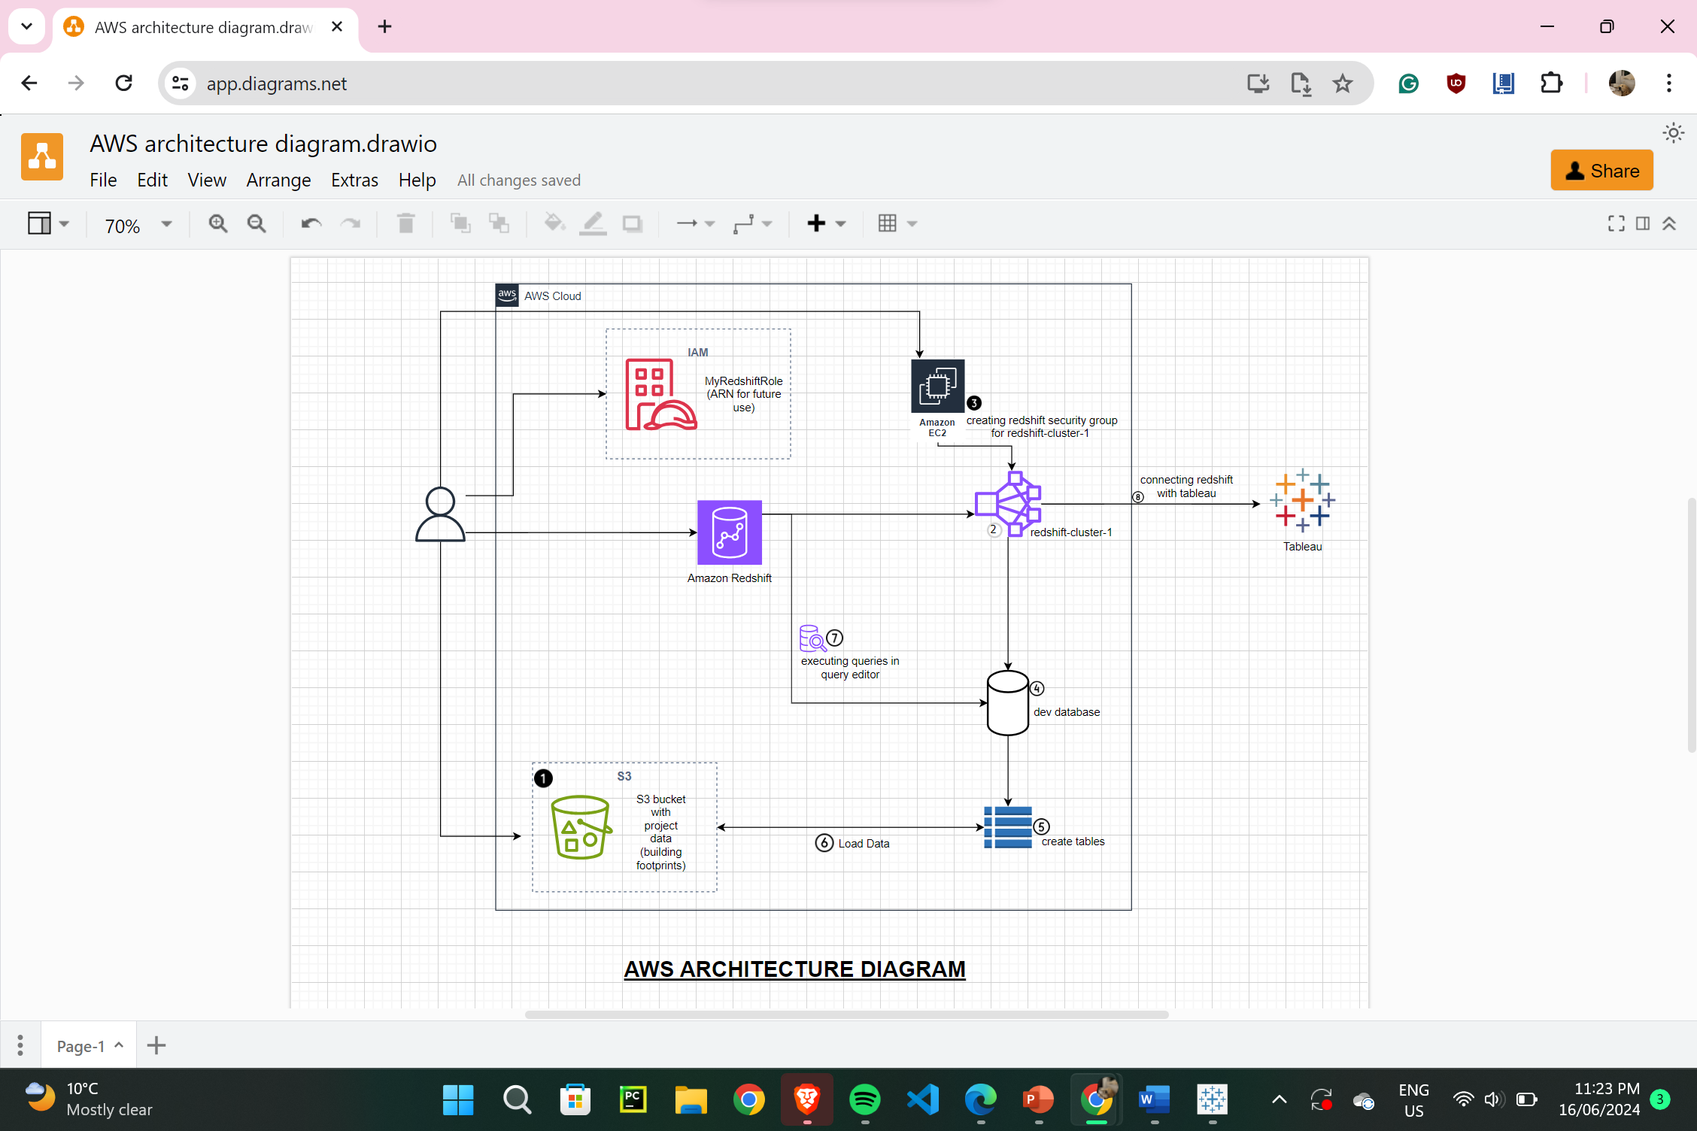

1. **Cleaning the project data through python:**

(since there were errors while \loading data)

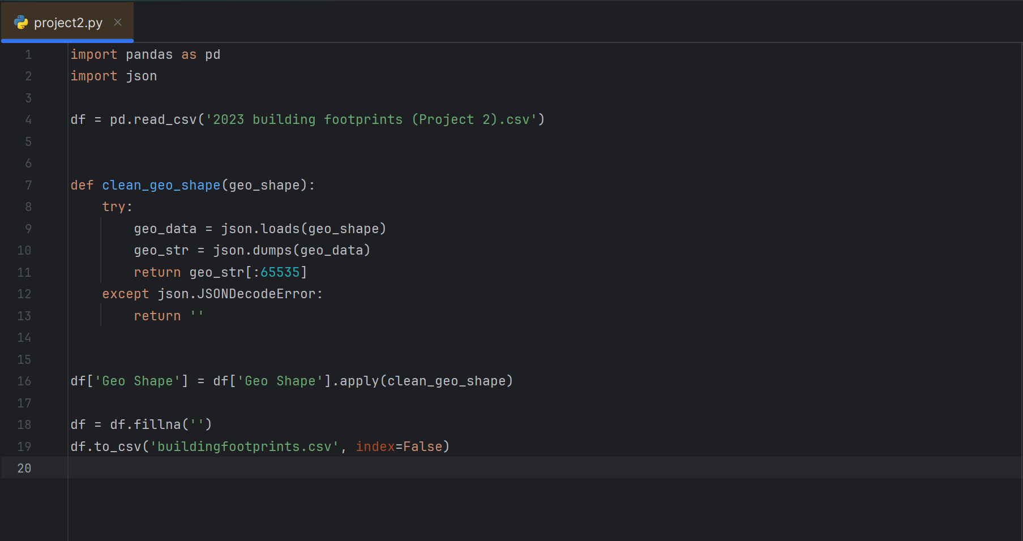

1. **Creating S3 bucket:**

(Bucket Name - buildingfootprints)

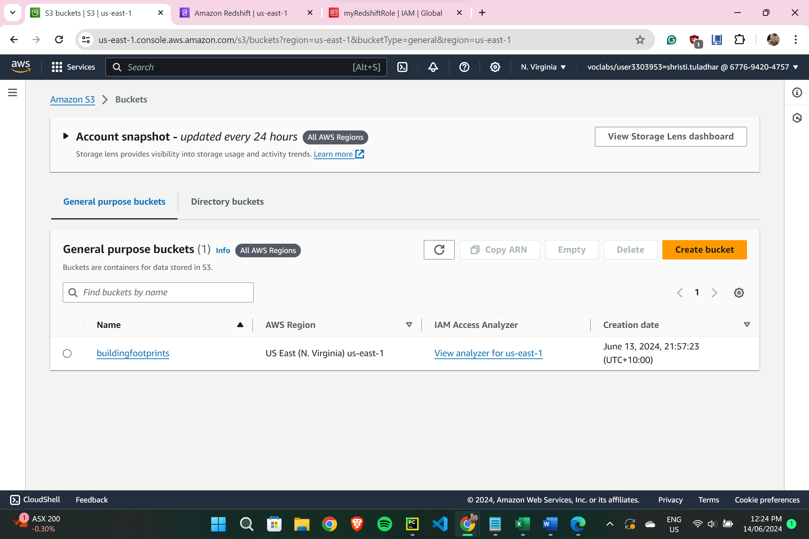

1. **Uploading the cleaned project data (CSV file) in S3 bucket:**

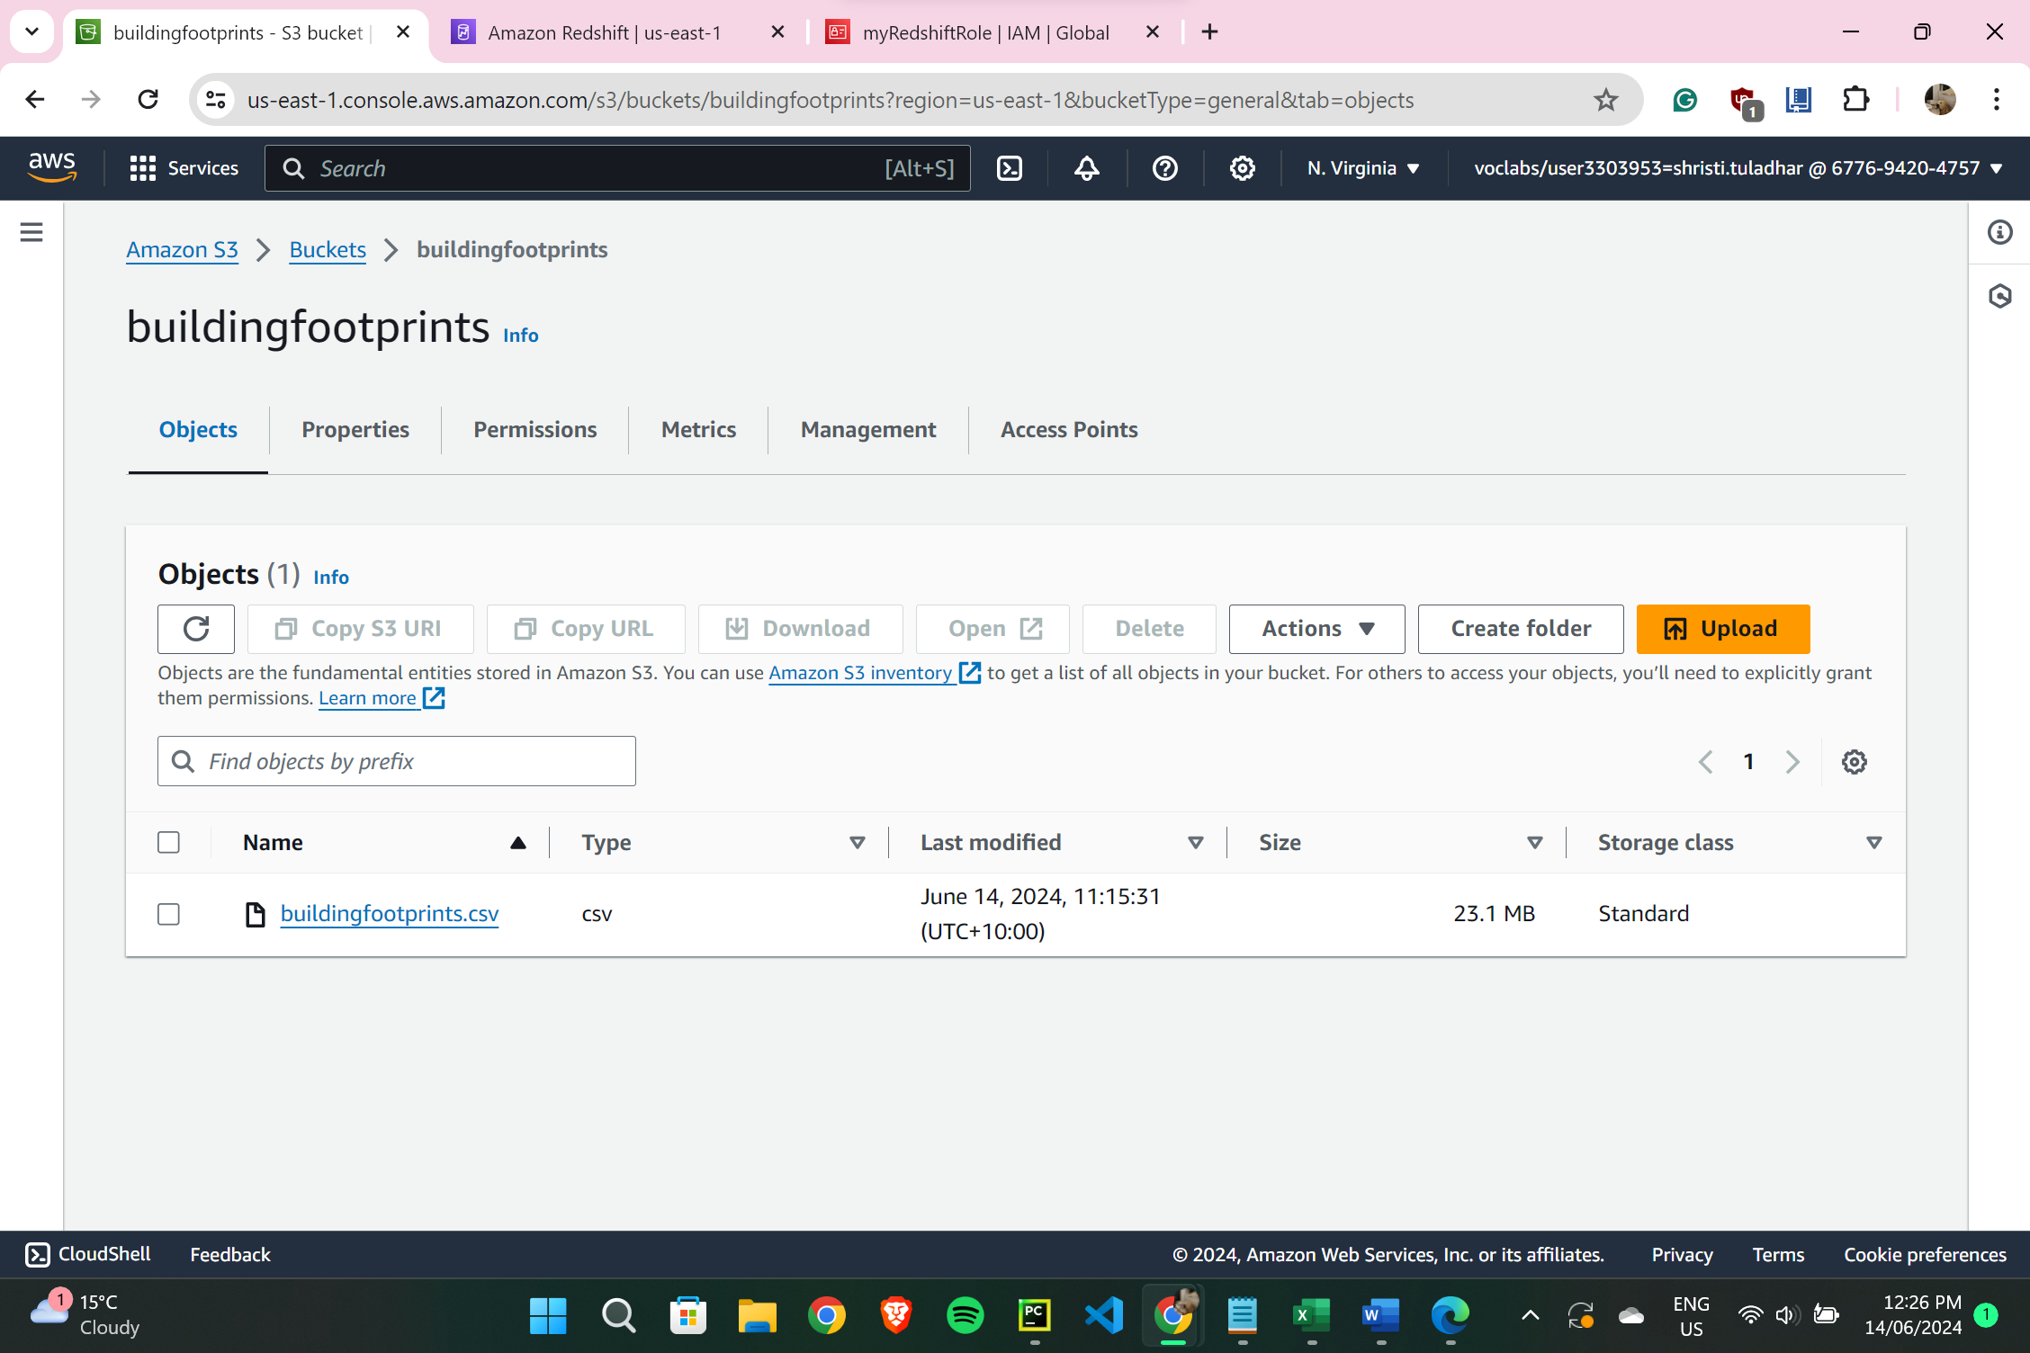

1. **Reviewing Amazon Redshift Settings:**

(Services IAM - Roles - myRedshiftRole) *(ARN copied for future use)*

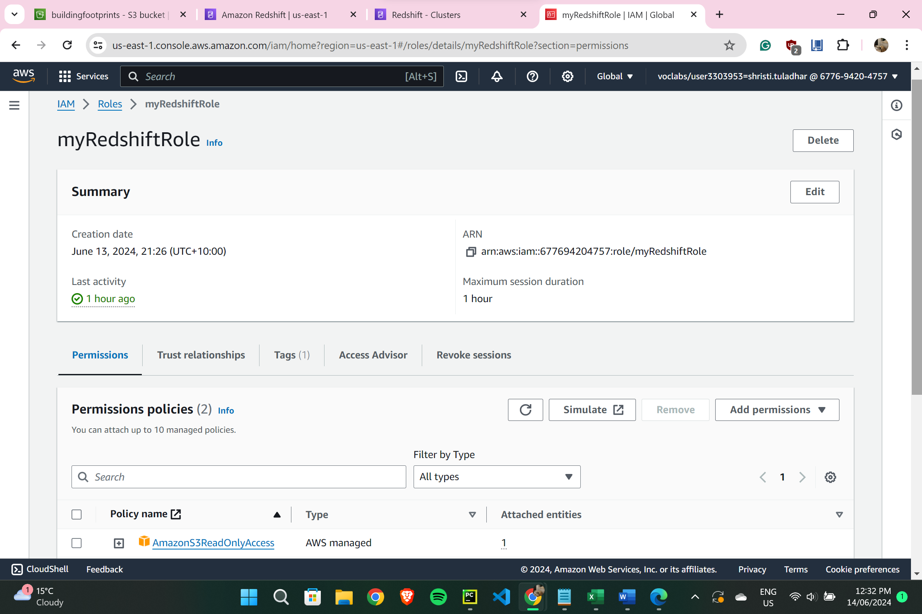

1. **Creating Redshift Cluster:**

(Amazon Redshift Console – Create Cluster; Name = Redshift Cluster 1, with nodes = 2, node type = dc2.large, password = Passw0rd1, and “myredshiftrole” as associated IAM roles)

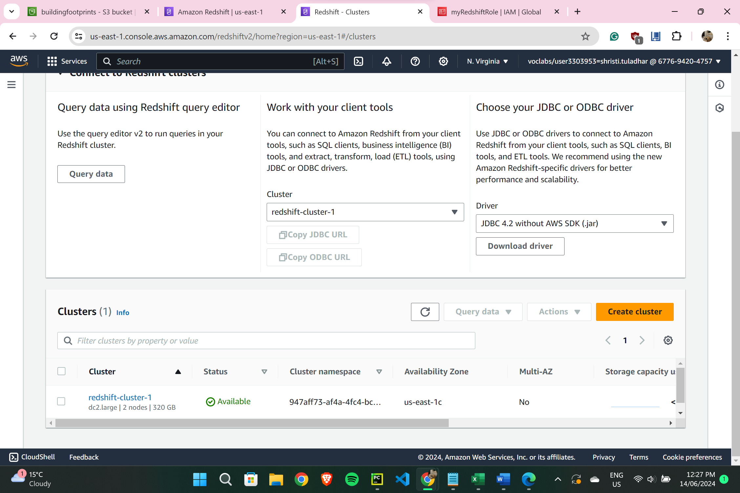

1. **Reviewing Amazon Redshift security settings & creating a security group:**

(EC2 Console – Network & Security – Security Groups, then creating a security group with Name: Redshift Security Group, Description: Security Group for My Redshift Cluster, Inbound Rules (Type: Redshift, Source: Anywhere IPv4, Description: Redshift inbound rule))

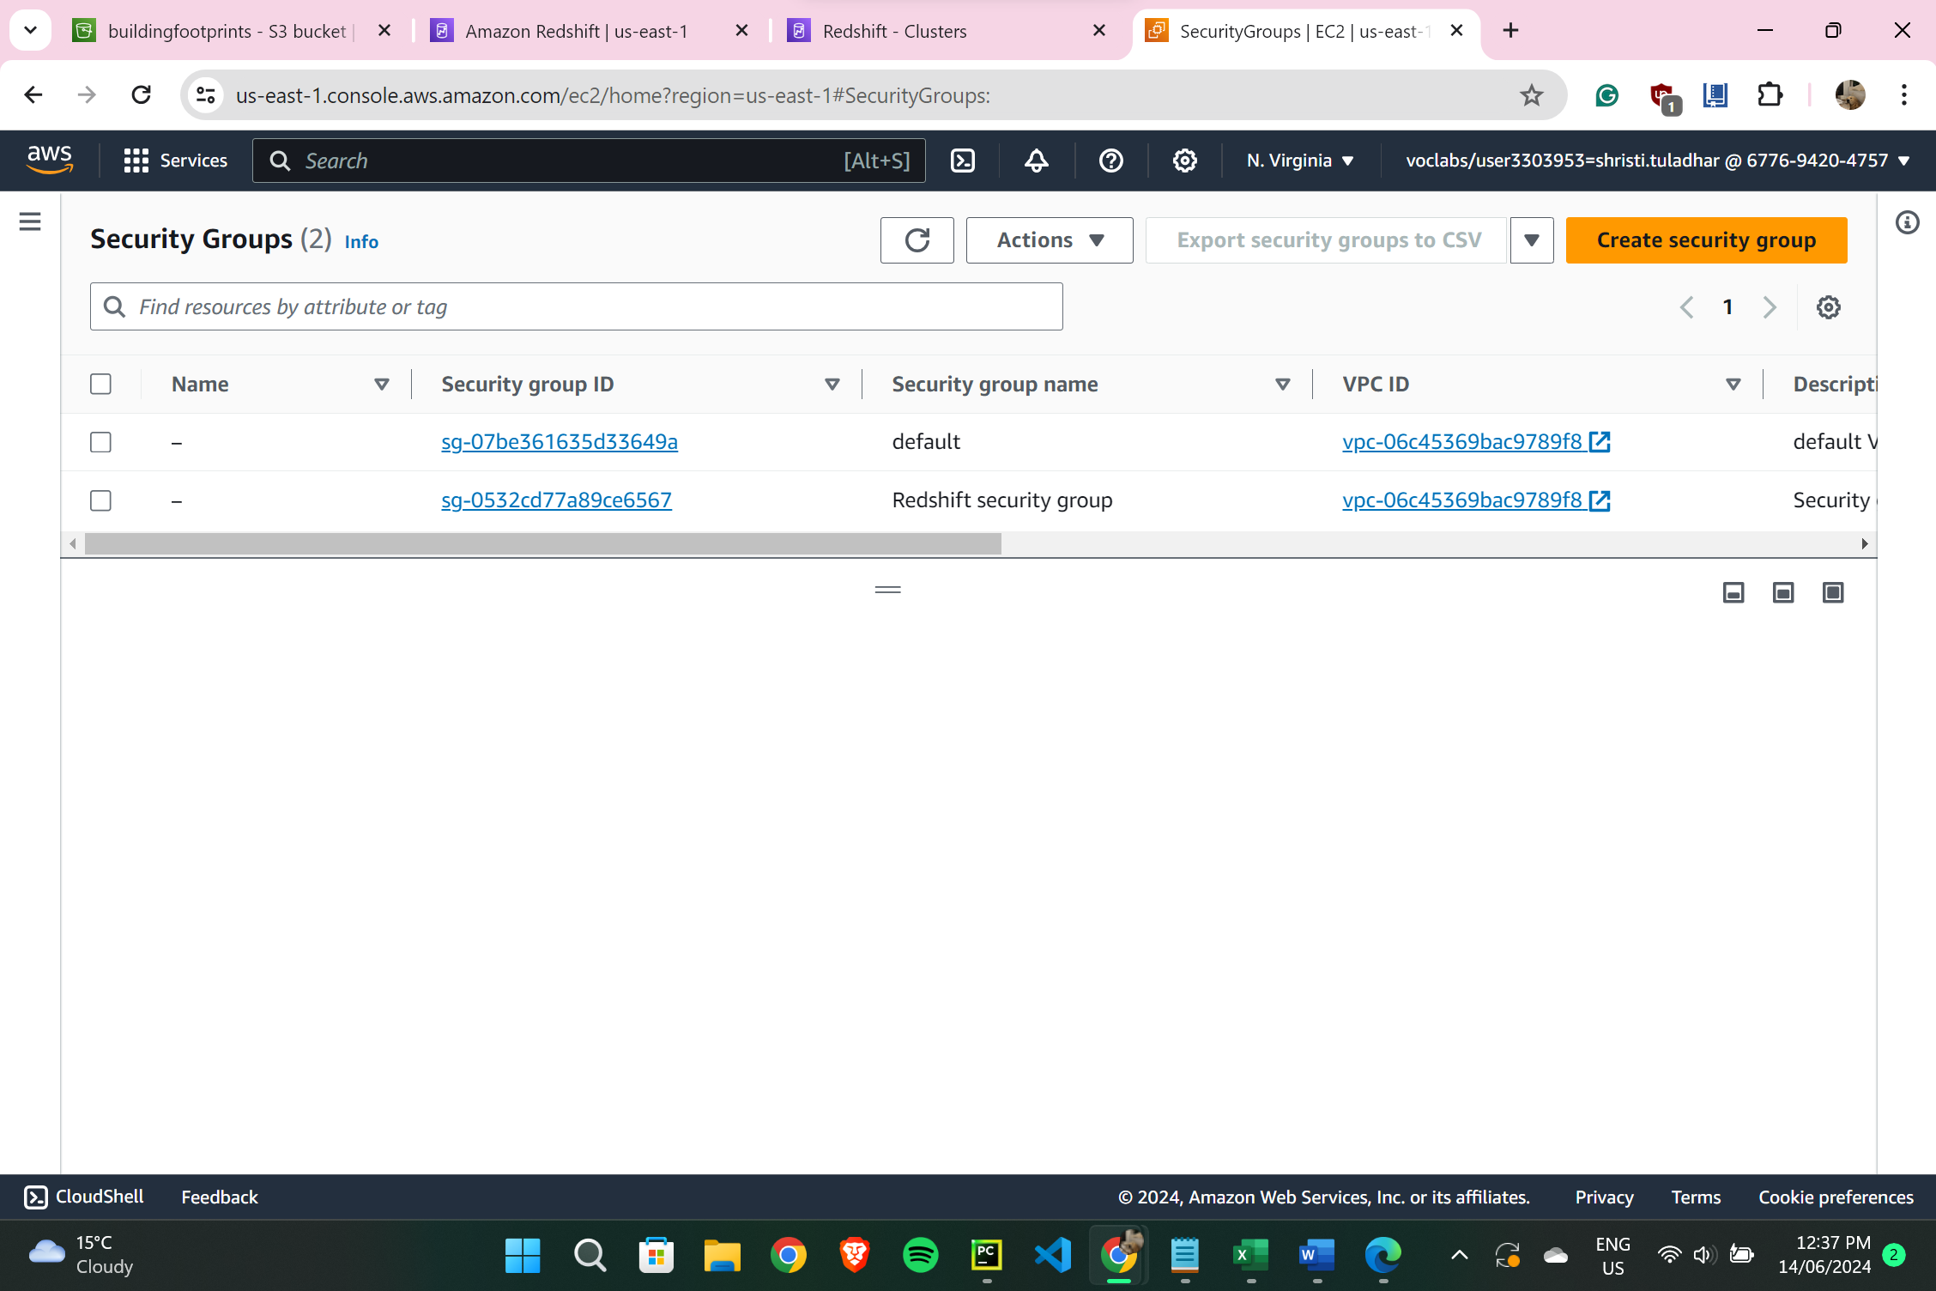

1. **Editing security settings for redshift cluster:**

(Redshift Cluster 1 – Properties – Network & Security section – Edit, then changing VPC security groups to Redshift security group and clearing default)

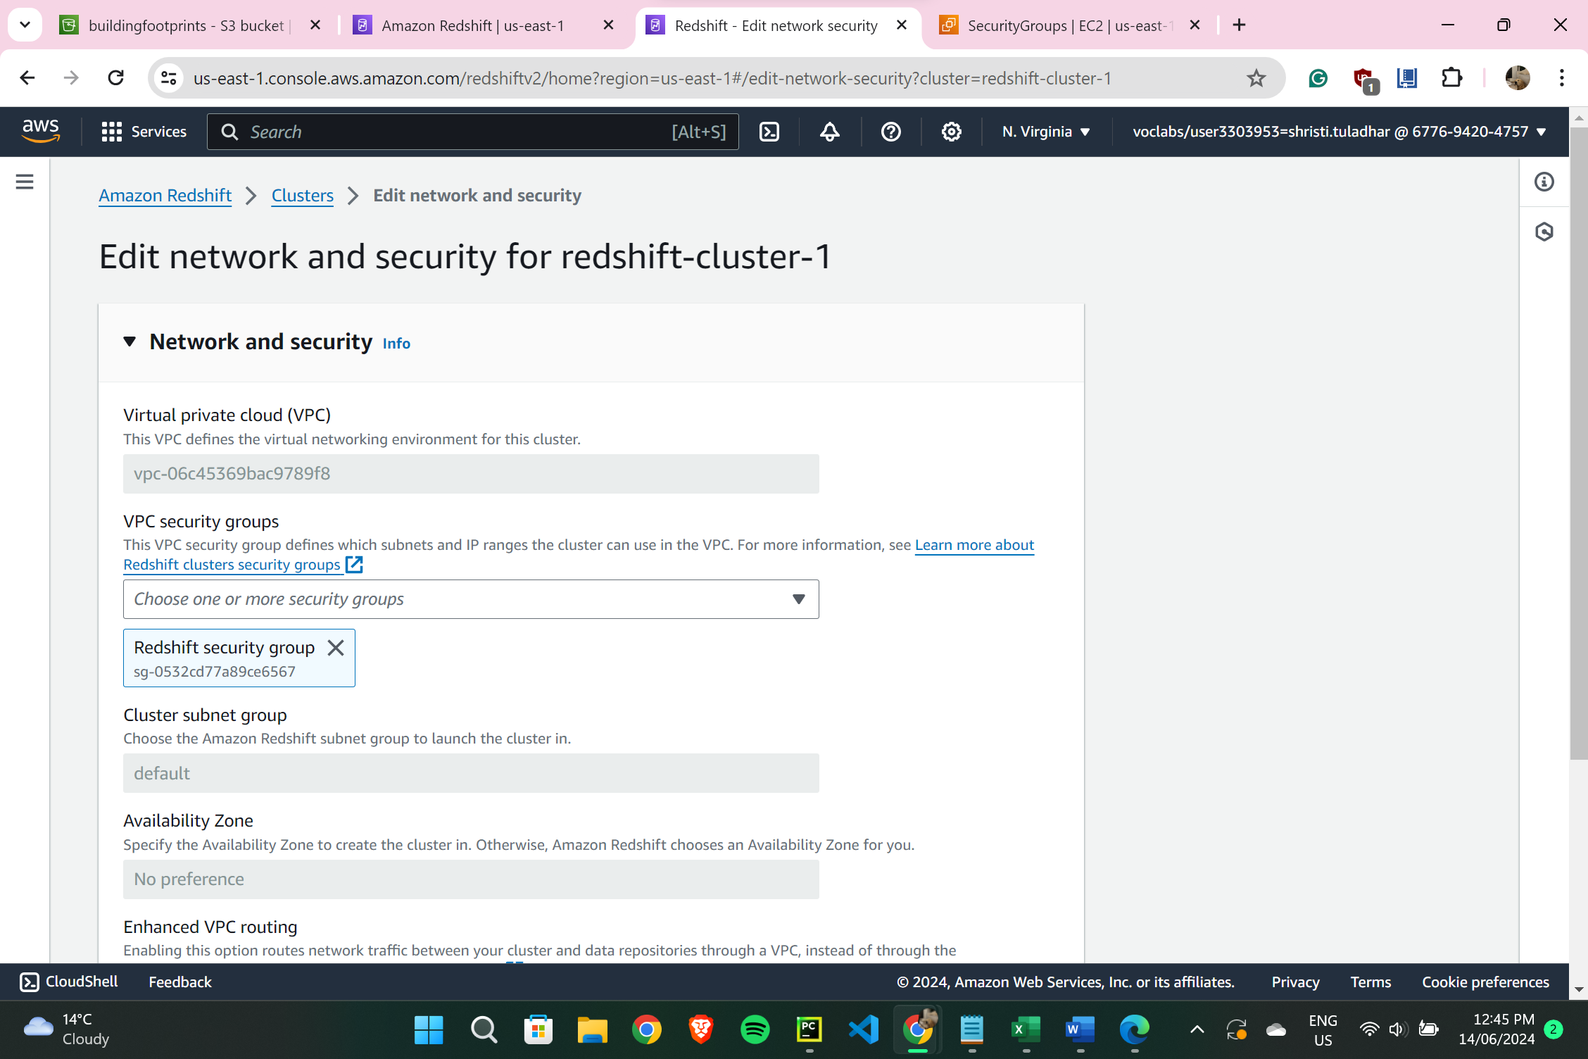

1. **Connecting with dev database:**

(Amazon Redshift – Redshift Cluster 1 – Query Data – Query in Query Editor – Choosing Connect to Database – Create a new connection, Choose redshift cluster 1, Database name = ‘dev’ and Database user = ‘awsuser’ and in reference panel on left side, schema = public)

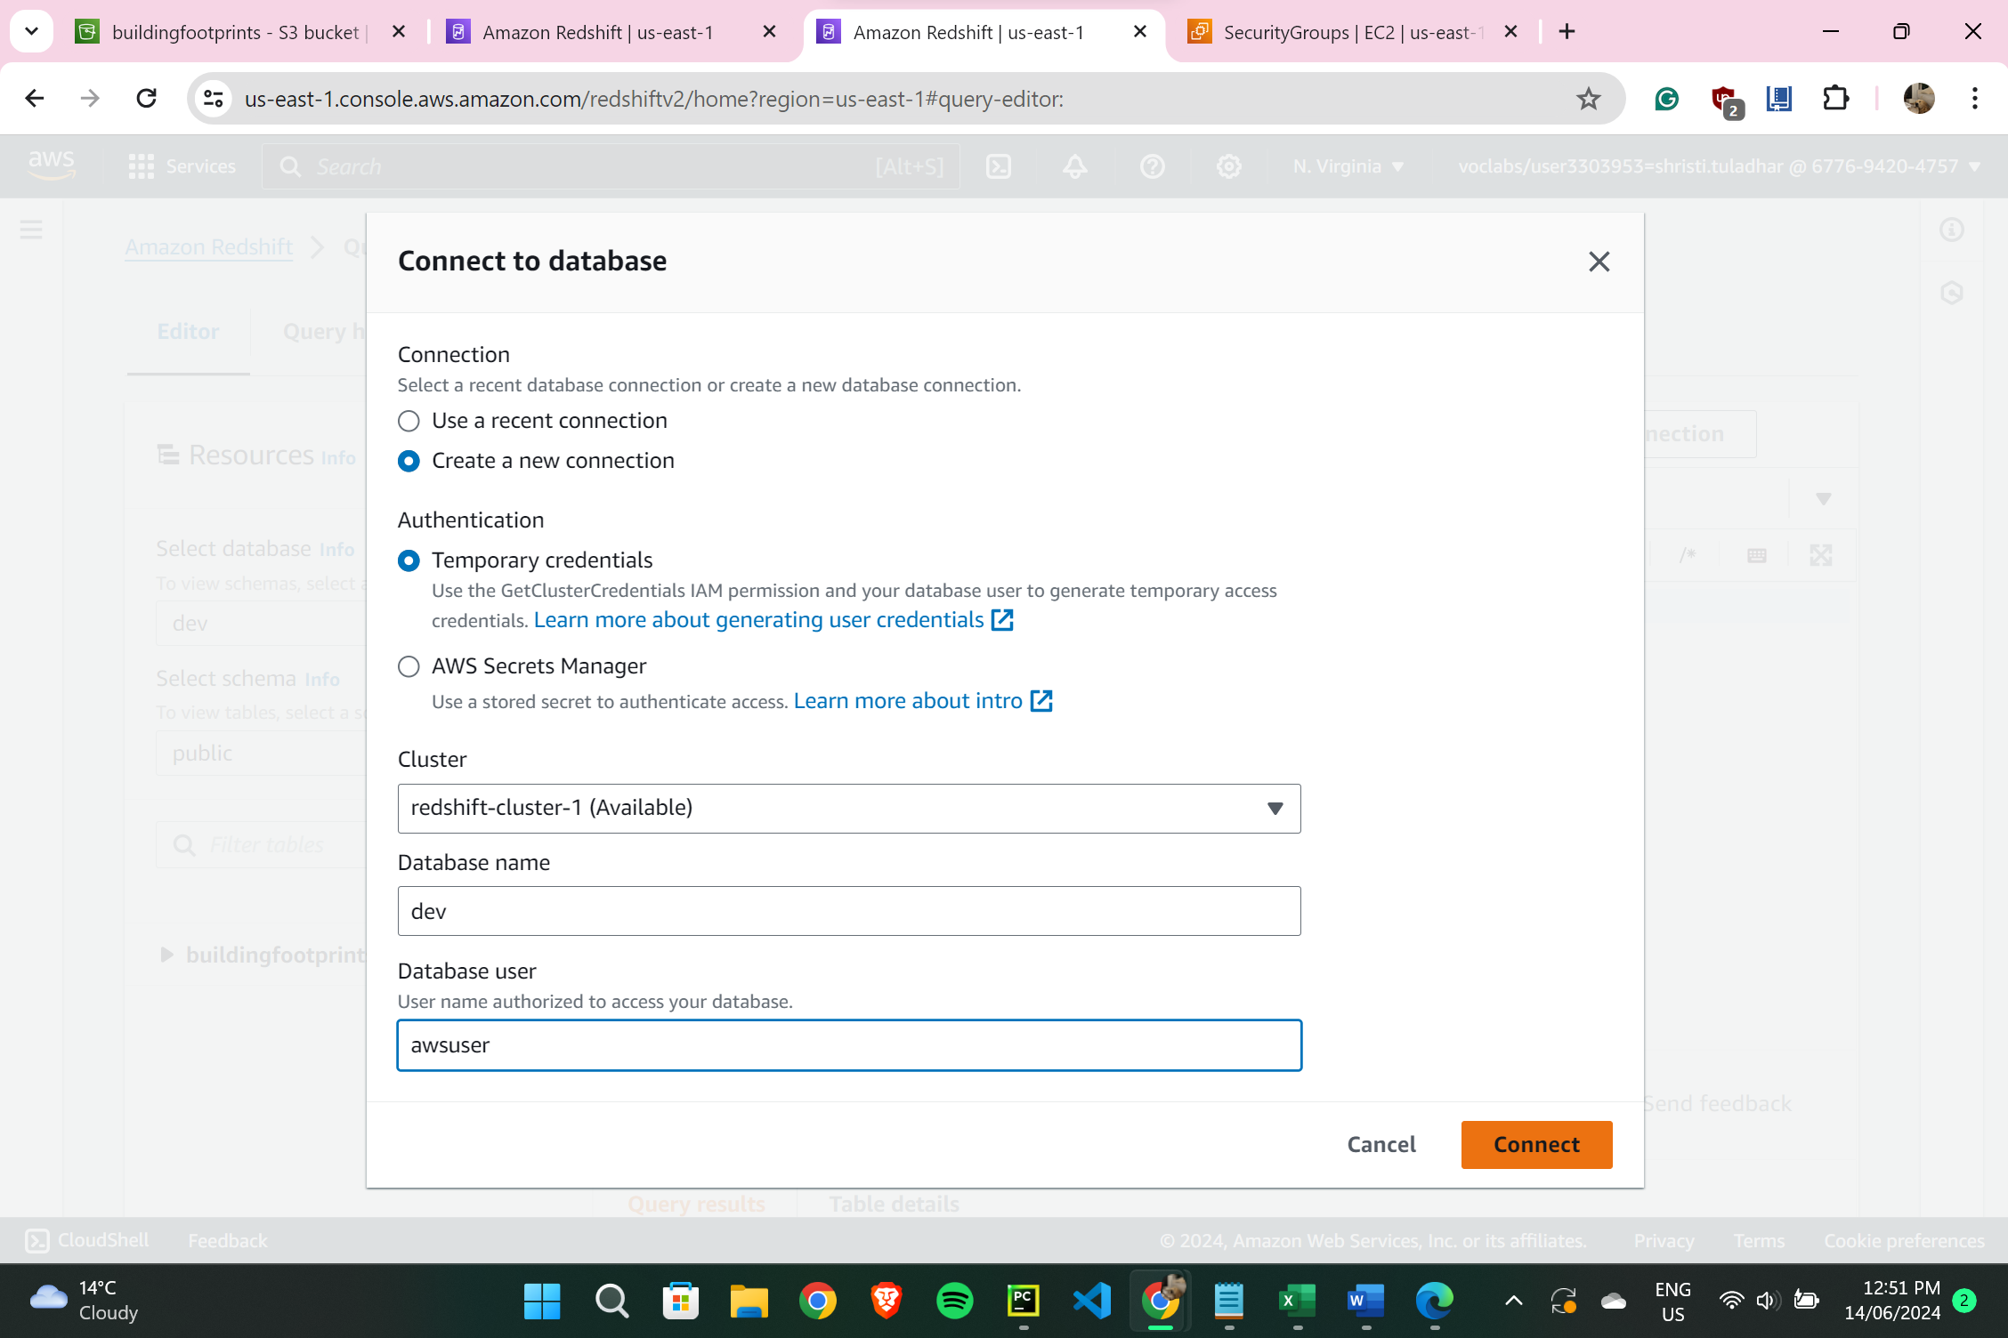

1. **Creating a Table with SQL that matches exactly with project file in Redshift Cluster:**

* *SQL Command:*

CREATE TABLE buildingfootprints (

geo_point VARCHAR(500),

geo_shape VARCHAR(MAX),

objectid INTEGER,

structure_id INTEGER,

footprint_type VARCHAR(50),

roof_type VARCHAR(50),

footprint_max_elevation FLOAT,

footprint_min_elevation FLOAT,

structure_max_elevation FLOAT,

structure_min_elevation FLOAT,

footprint_extrusion FLOAT,

structure_extrusion FLOAT,

date_captured DATE

);

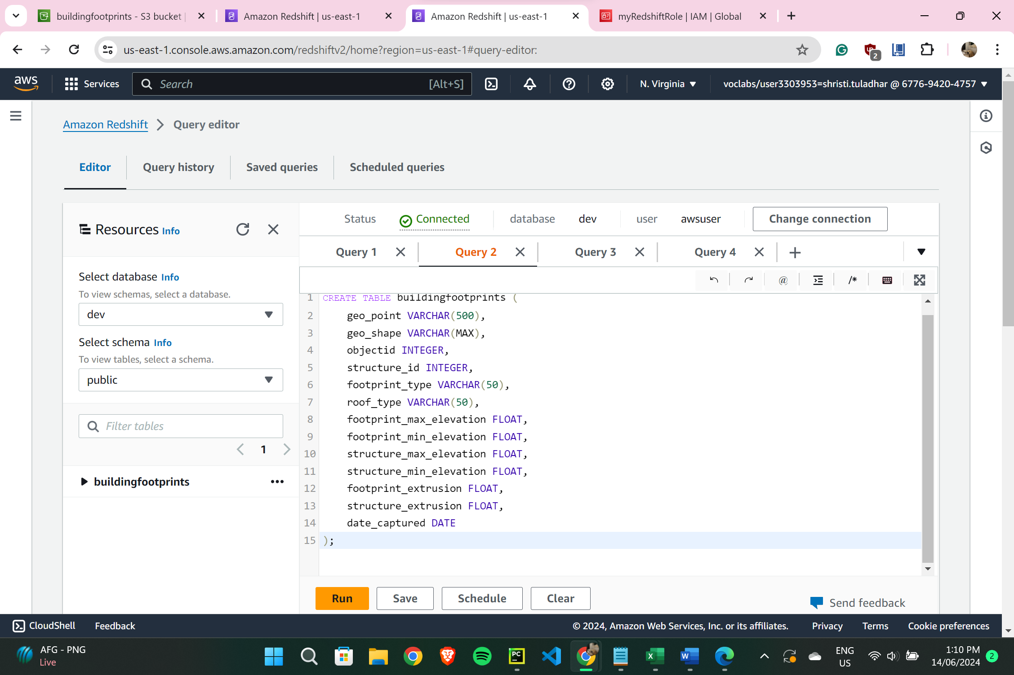

1. **Loading project data from S3 in Redshift Cluster in Query Editor:**

(copied S3 URL from the bucket ‘buildingfootprints’, & ARN from step4)

* *SQL Command:*

COPY buildingfootprints

FROM 's3://buildingfootprints/buildingfootprints.csv'

IAM_ROLE 'arn:aws:iam::677694204757:role/myRedshiftRole'

CSV

IGNOREHEADER 1

DATEFORMAT 'YYYYMMDD'

EMPTYASNULL

BLANKSASNULL

ACCEPTINVCHARS;

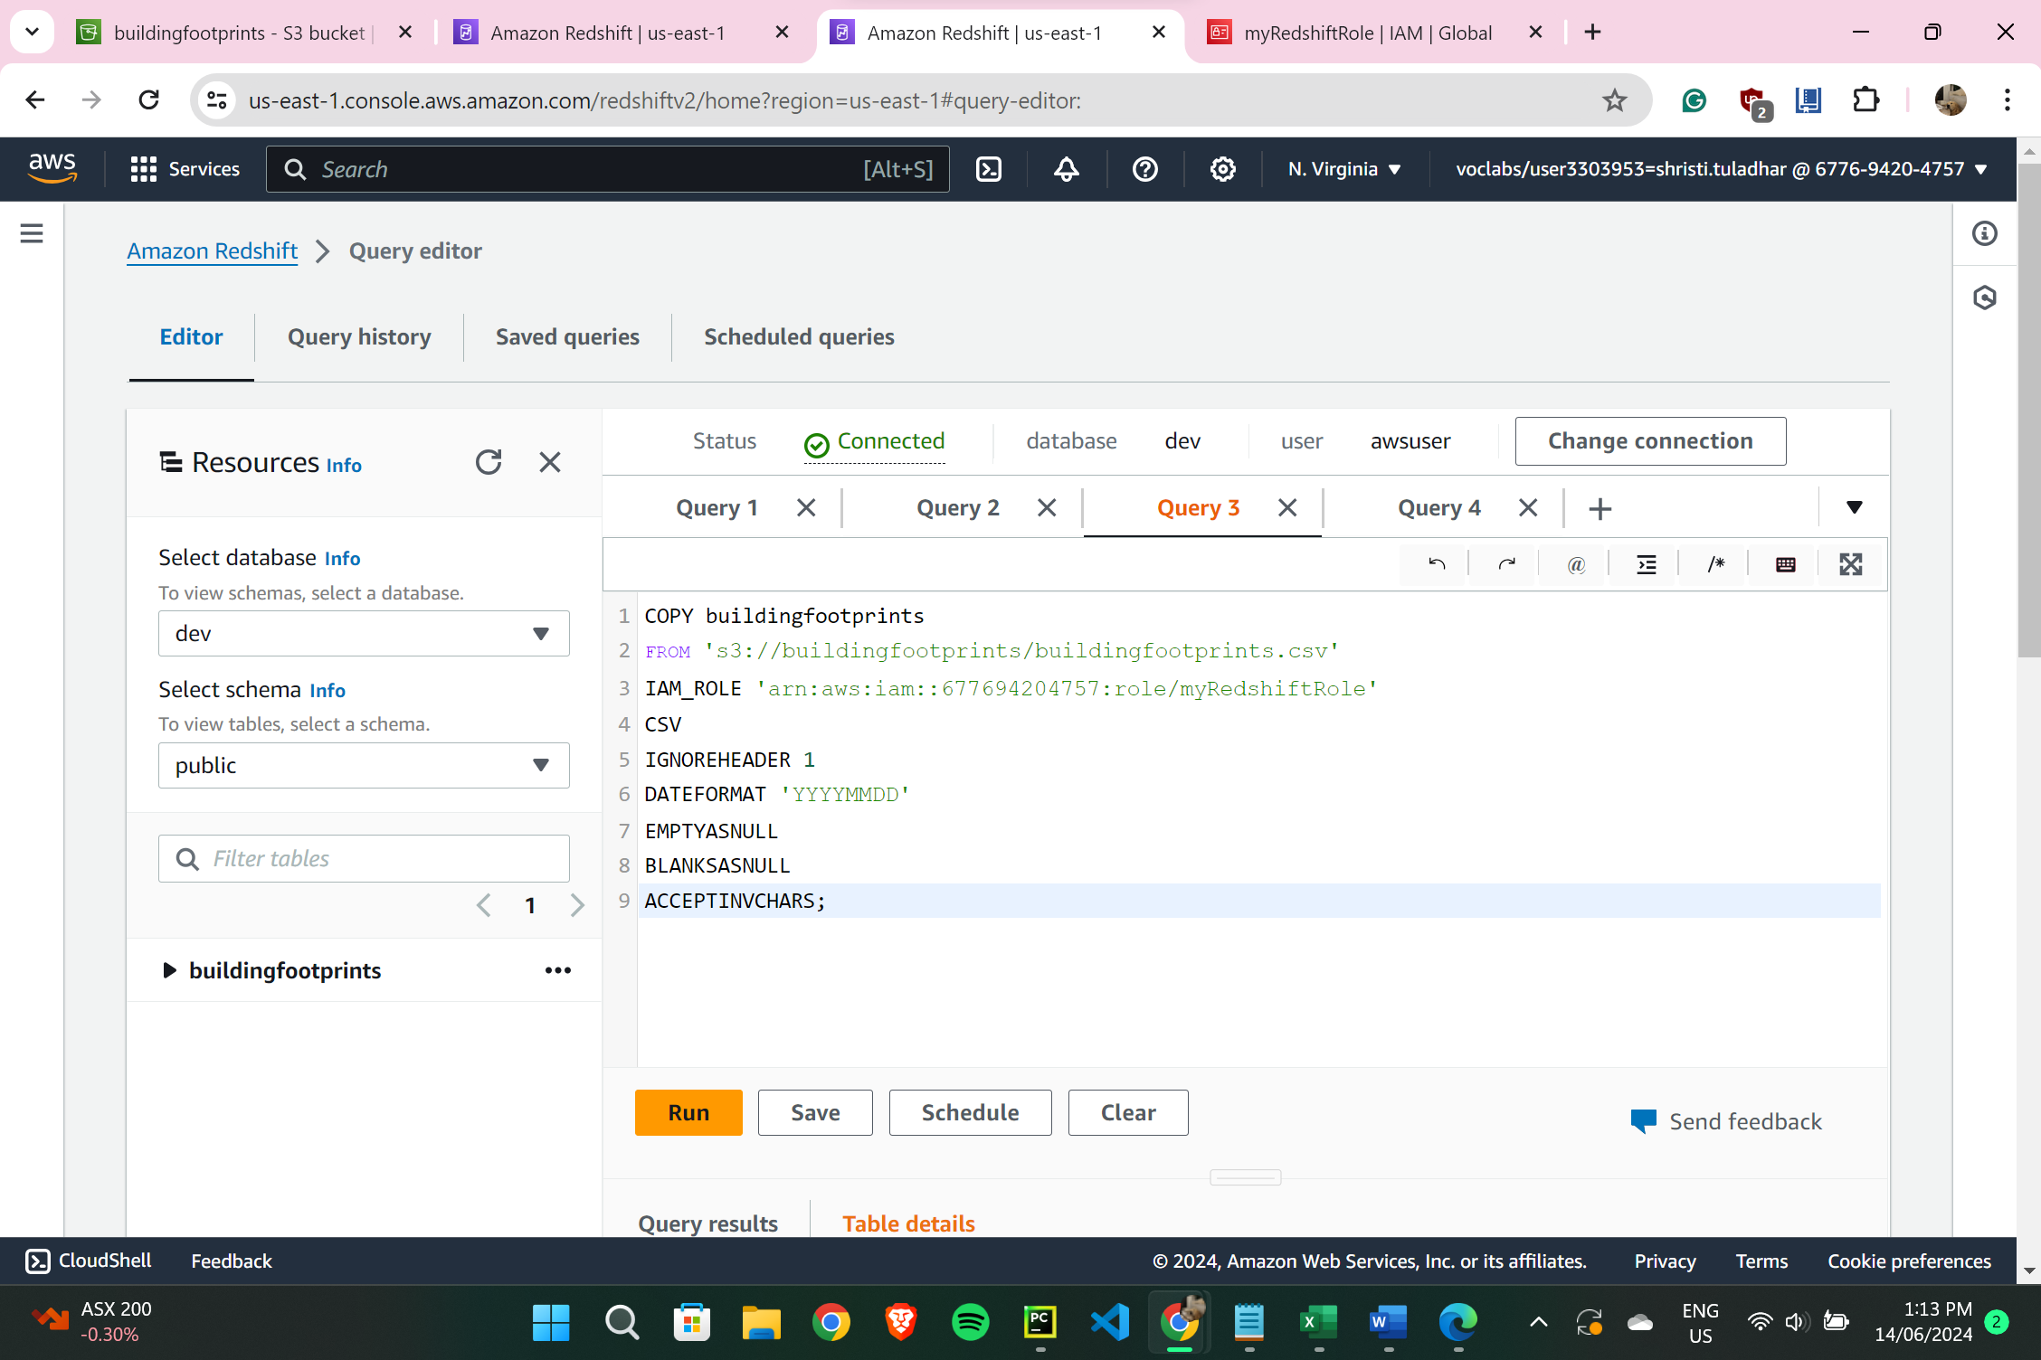

* **Found some errors while running this command (step10), which was debugged and rectified.**

1. **Previewing data of that table:**

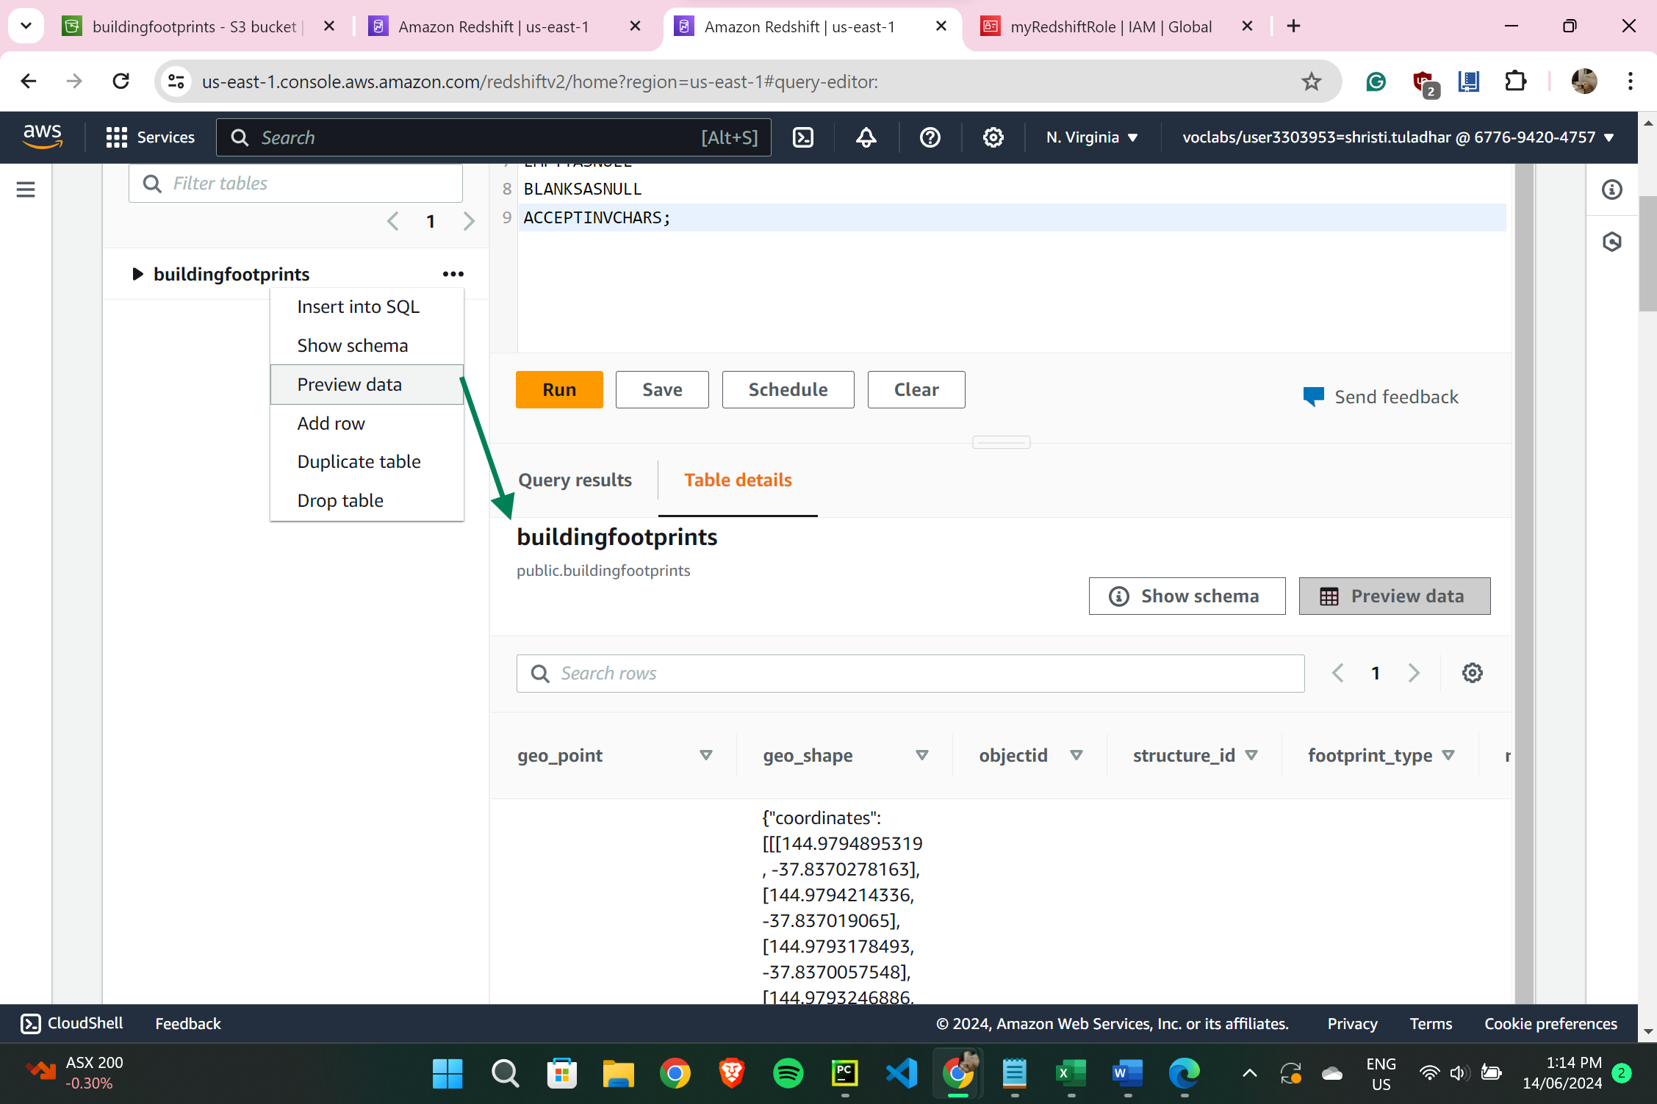

1. **Running FOUR queries:**

* Two Simple Queries:

1. Query 1: Selecting specific columns

SELECT geo_point, structure_id, footprint_type

FROM buildingfootprints

WHERE footprint_type = 'Structure' AND structure_id > 50000

LIMIT 10;

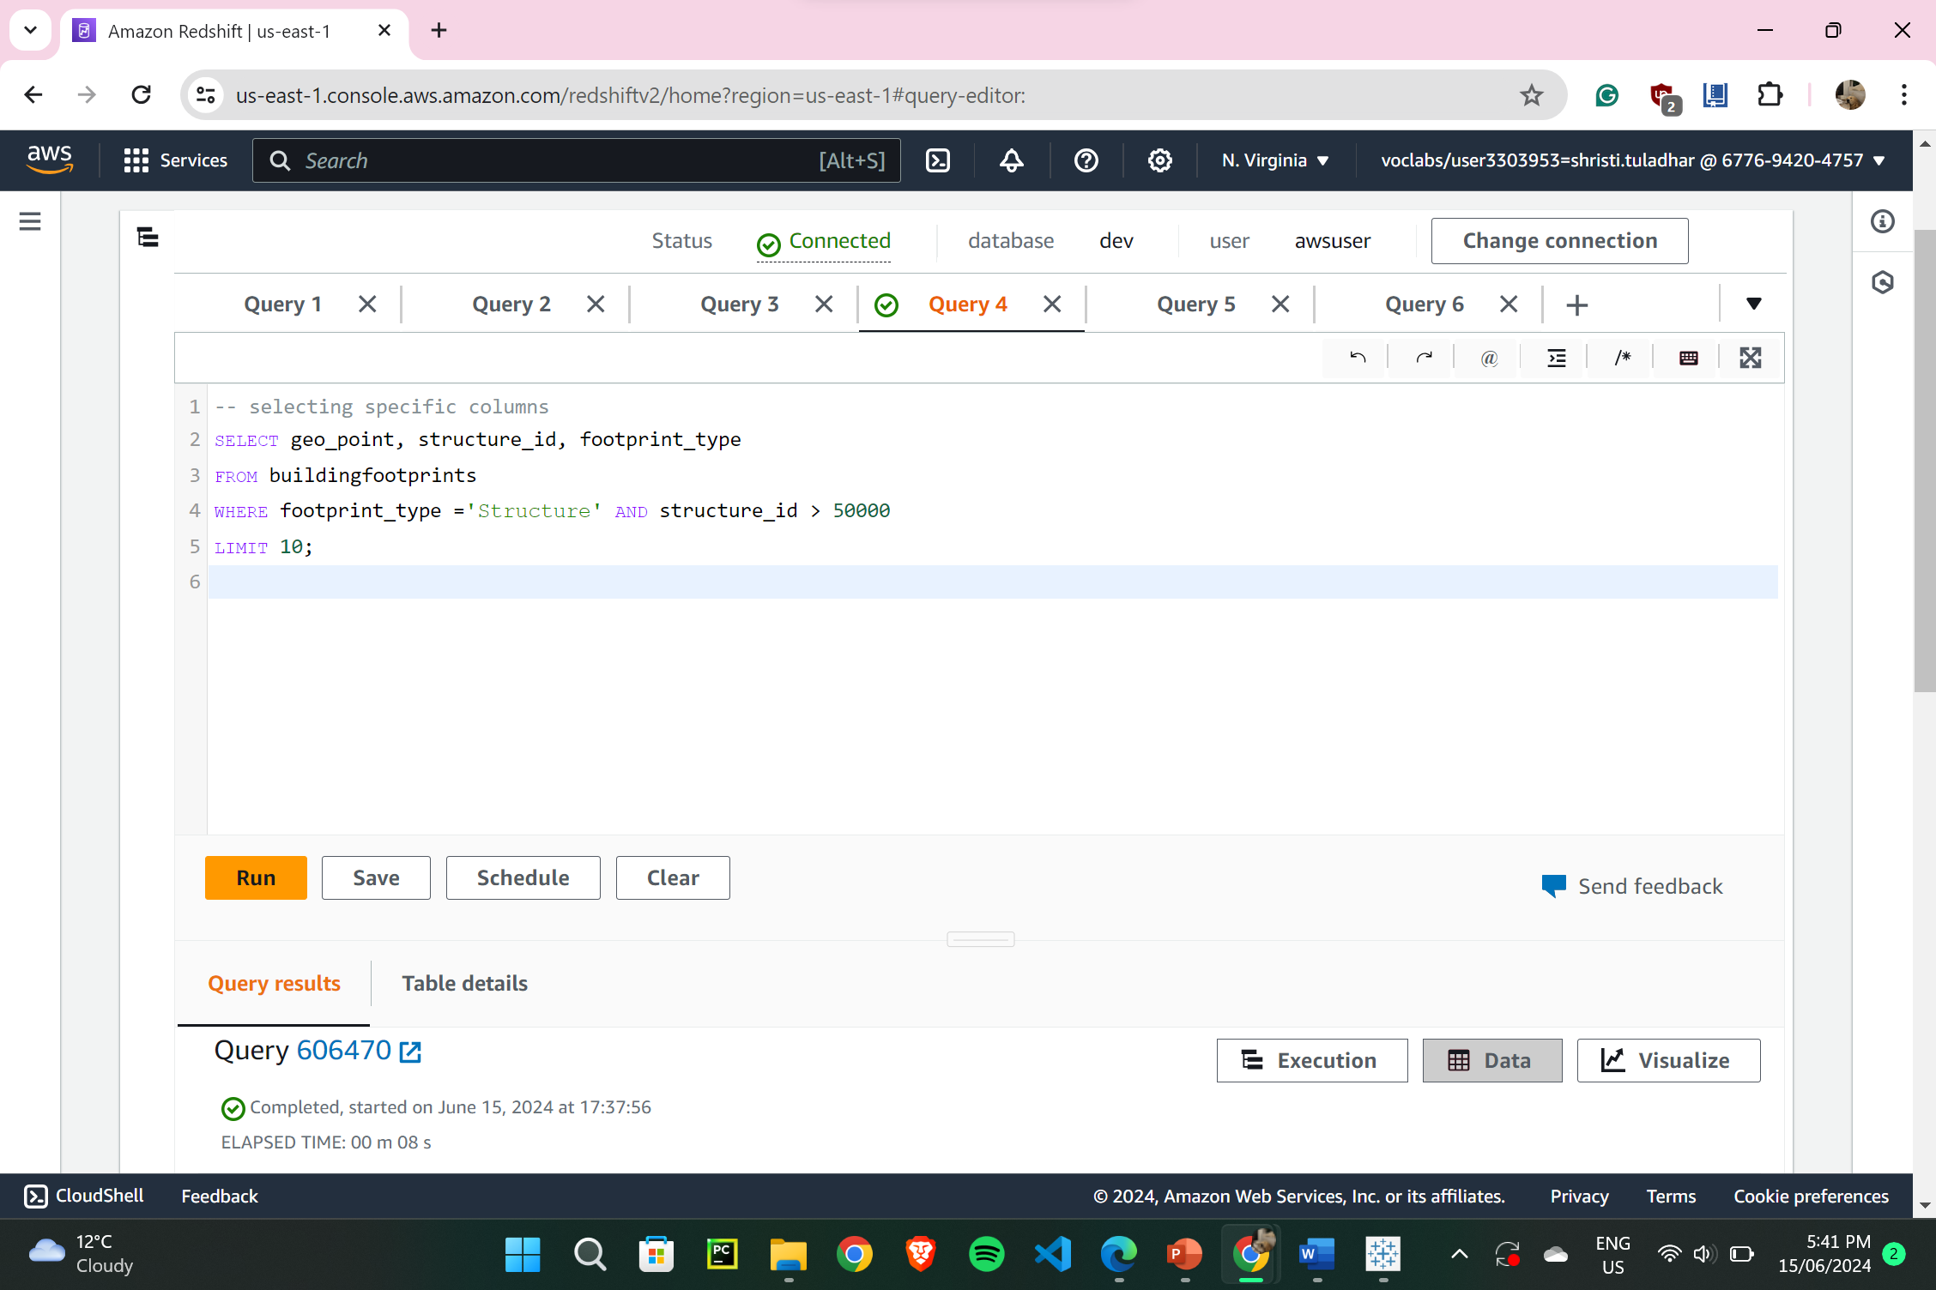

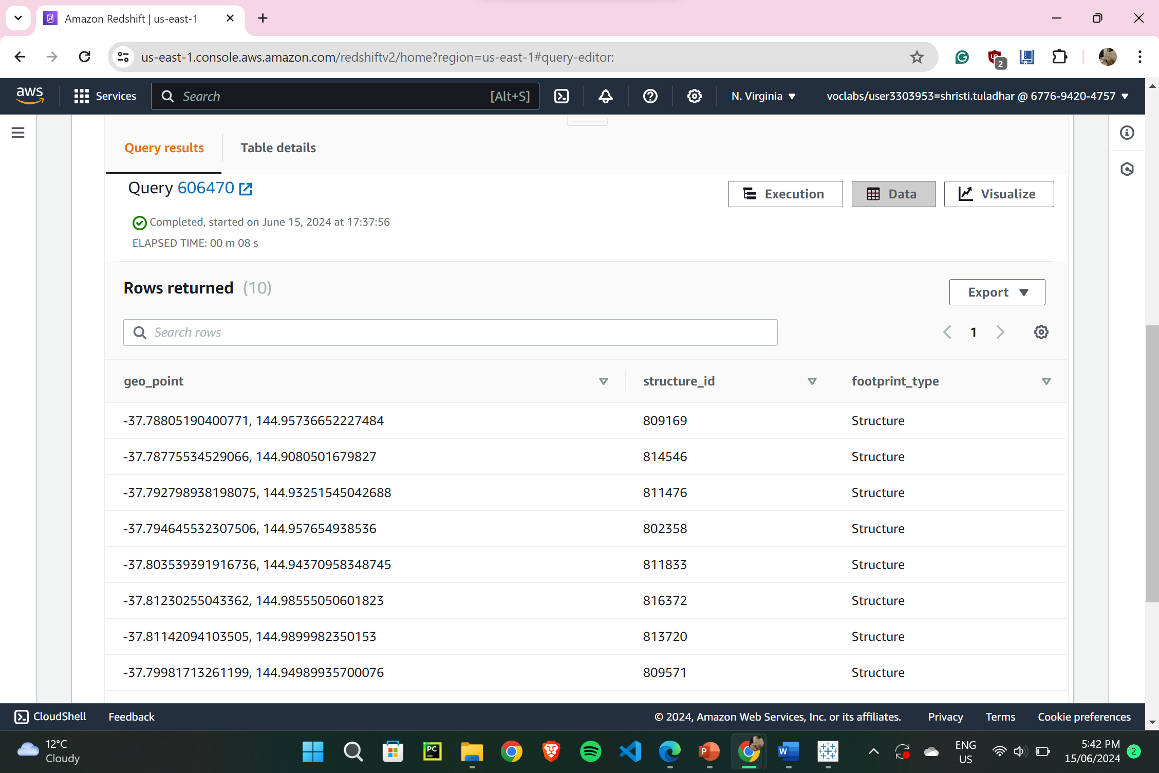

1. Query 2: Selecting with ORDER BY

SELECT *

FROM buildingfootprints

WHERE footprint_max_elevation > 20

ORDER BY structure_id DESC

LIMIT 10;

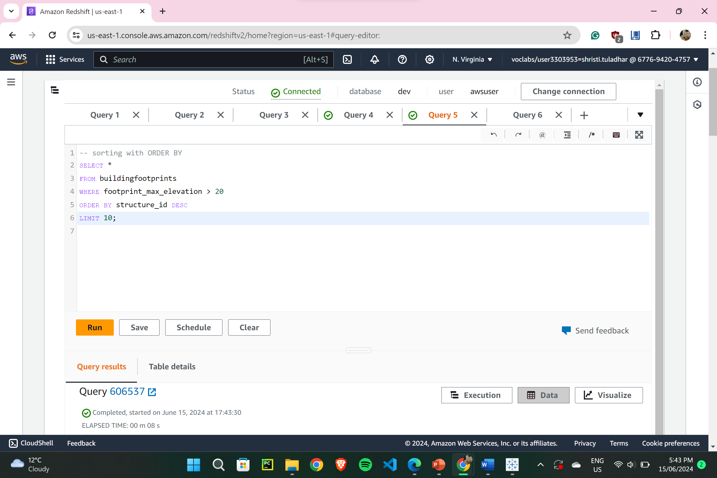

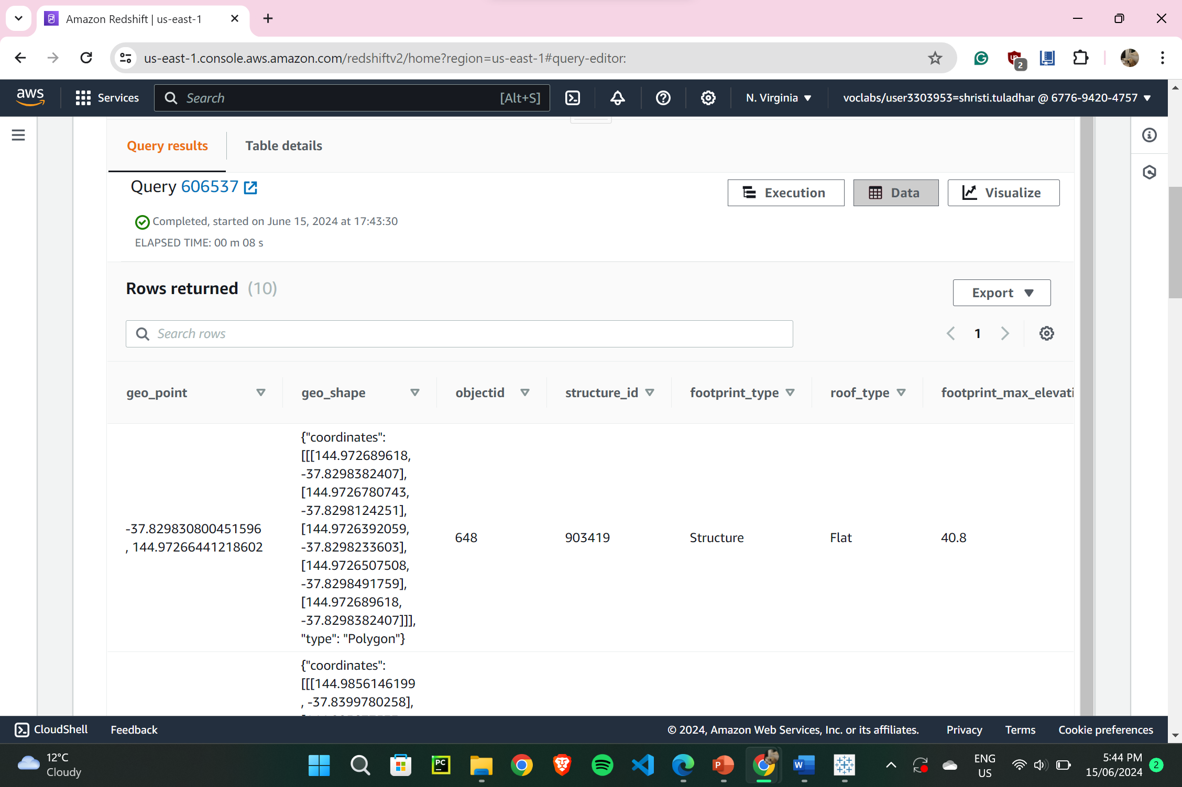

* Two Complex Queries:

1. Query 3: COUNT of Records by ‘footprint_type’

SELECT footprint_type, COUNT(*) AS count

FROM buildingfootprints

WHERE footprint_max_elevation > 10

GROUP BY footprint_type

HAVING COUNT(*) > 5

ORDER BY count DESC

LIMIT 5;

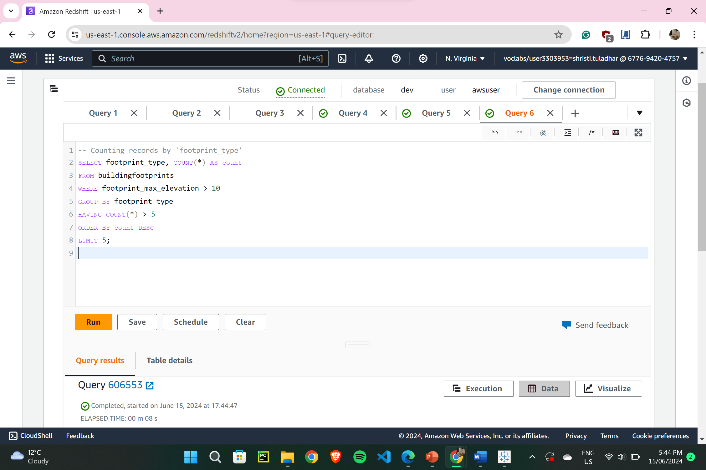

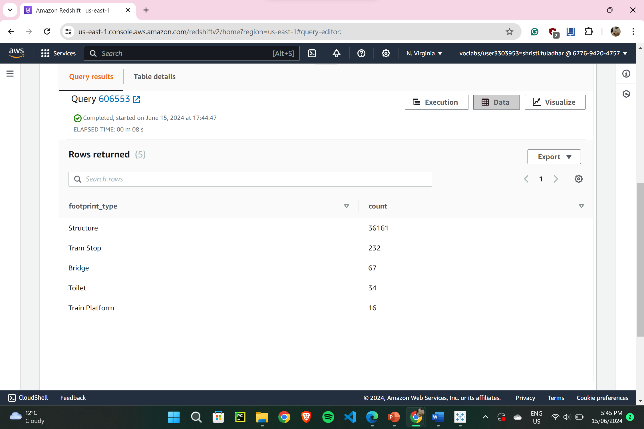

1. Query 4: SUM of ‘footprint_extrusion’ by ‘roof_type’

SELECT roof_type, SUM(footprint_extrusion) AS total_extrusion

FROM buildingfootprints

WHERE footprint_extrusion > 0

GROUP BY roof_type

HAVING SUM(footprint_extrusion) > 50

ORDER BY total_extrusion DESC

LIMIT 5;

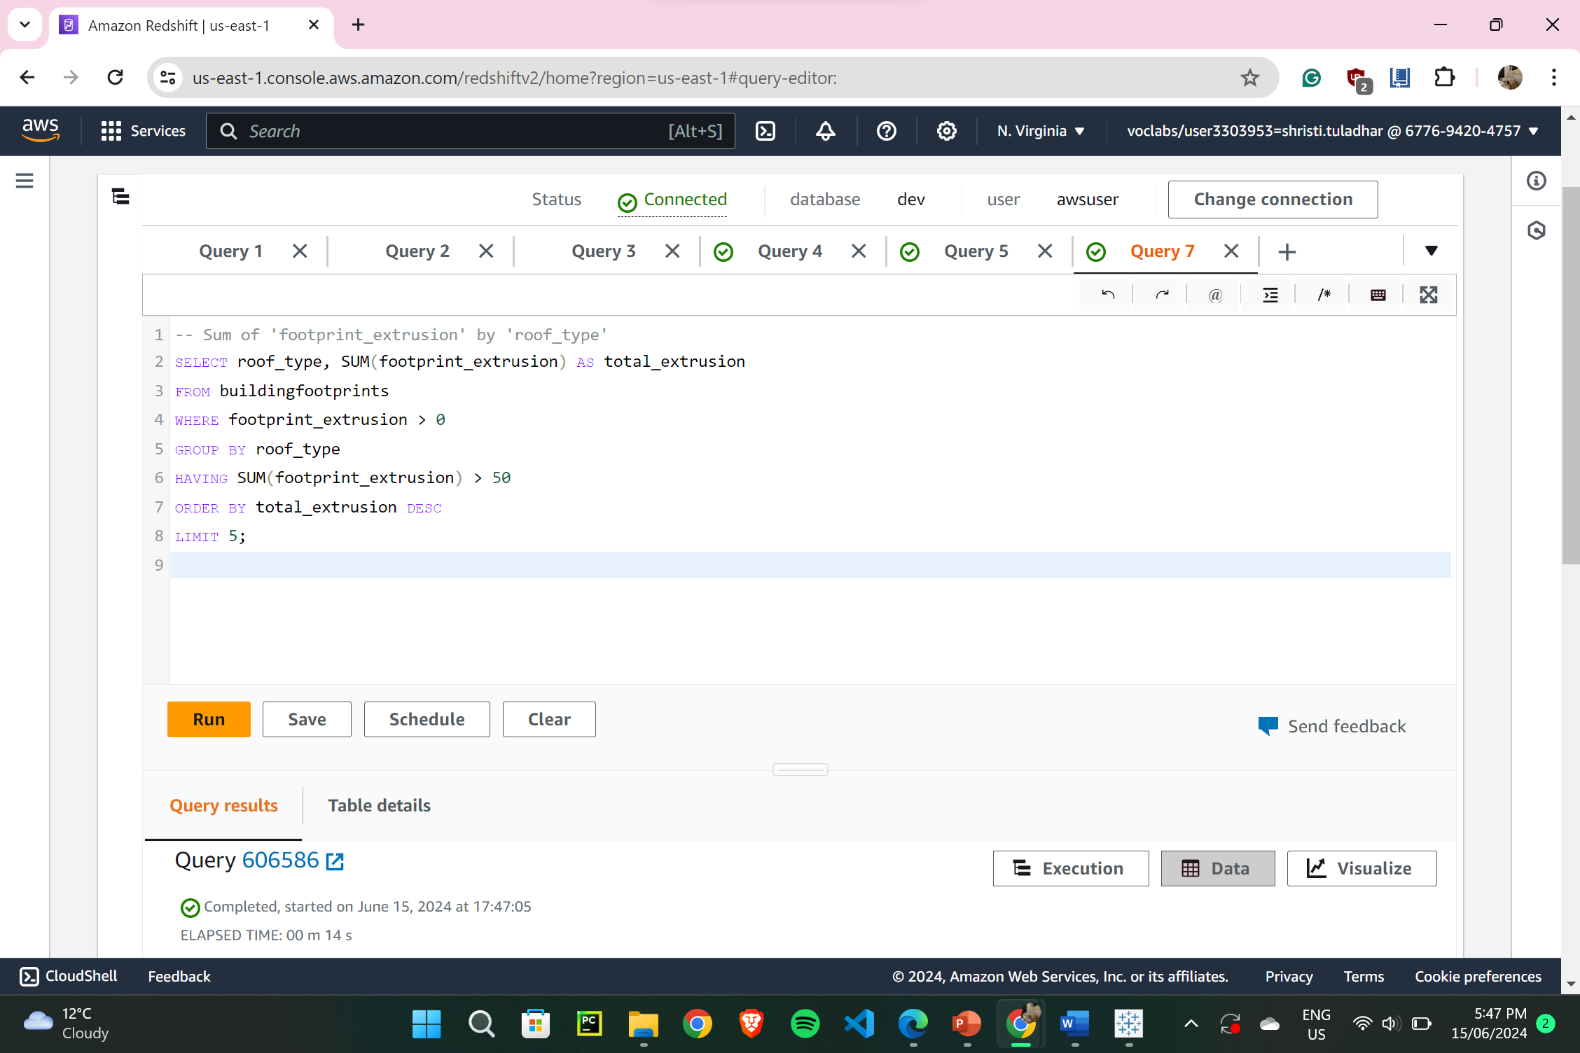

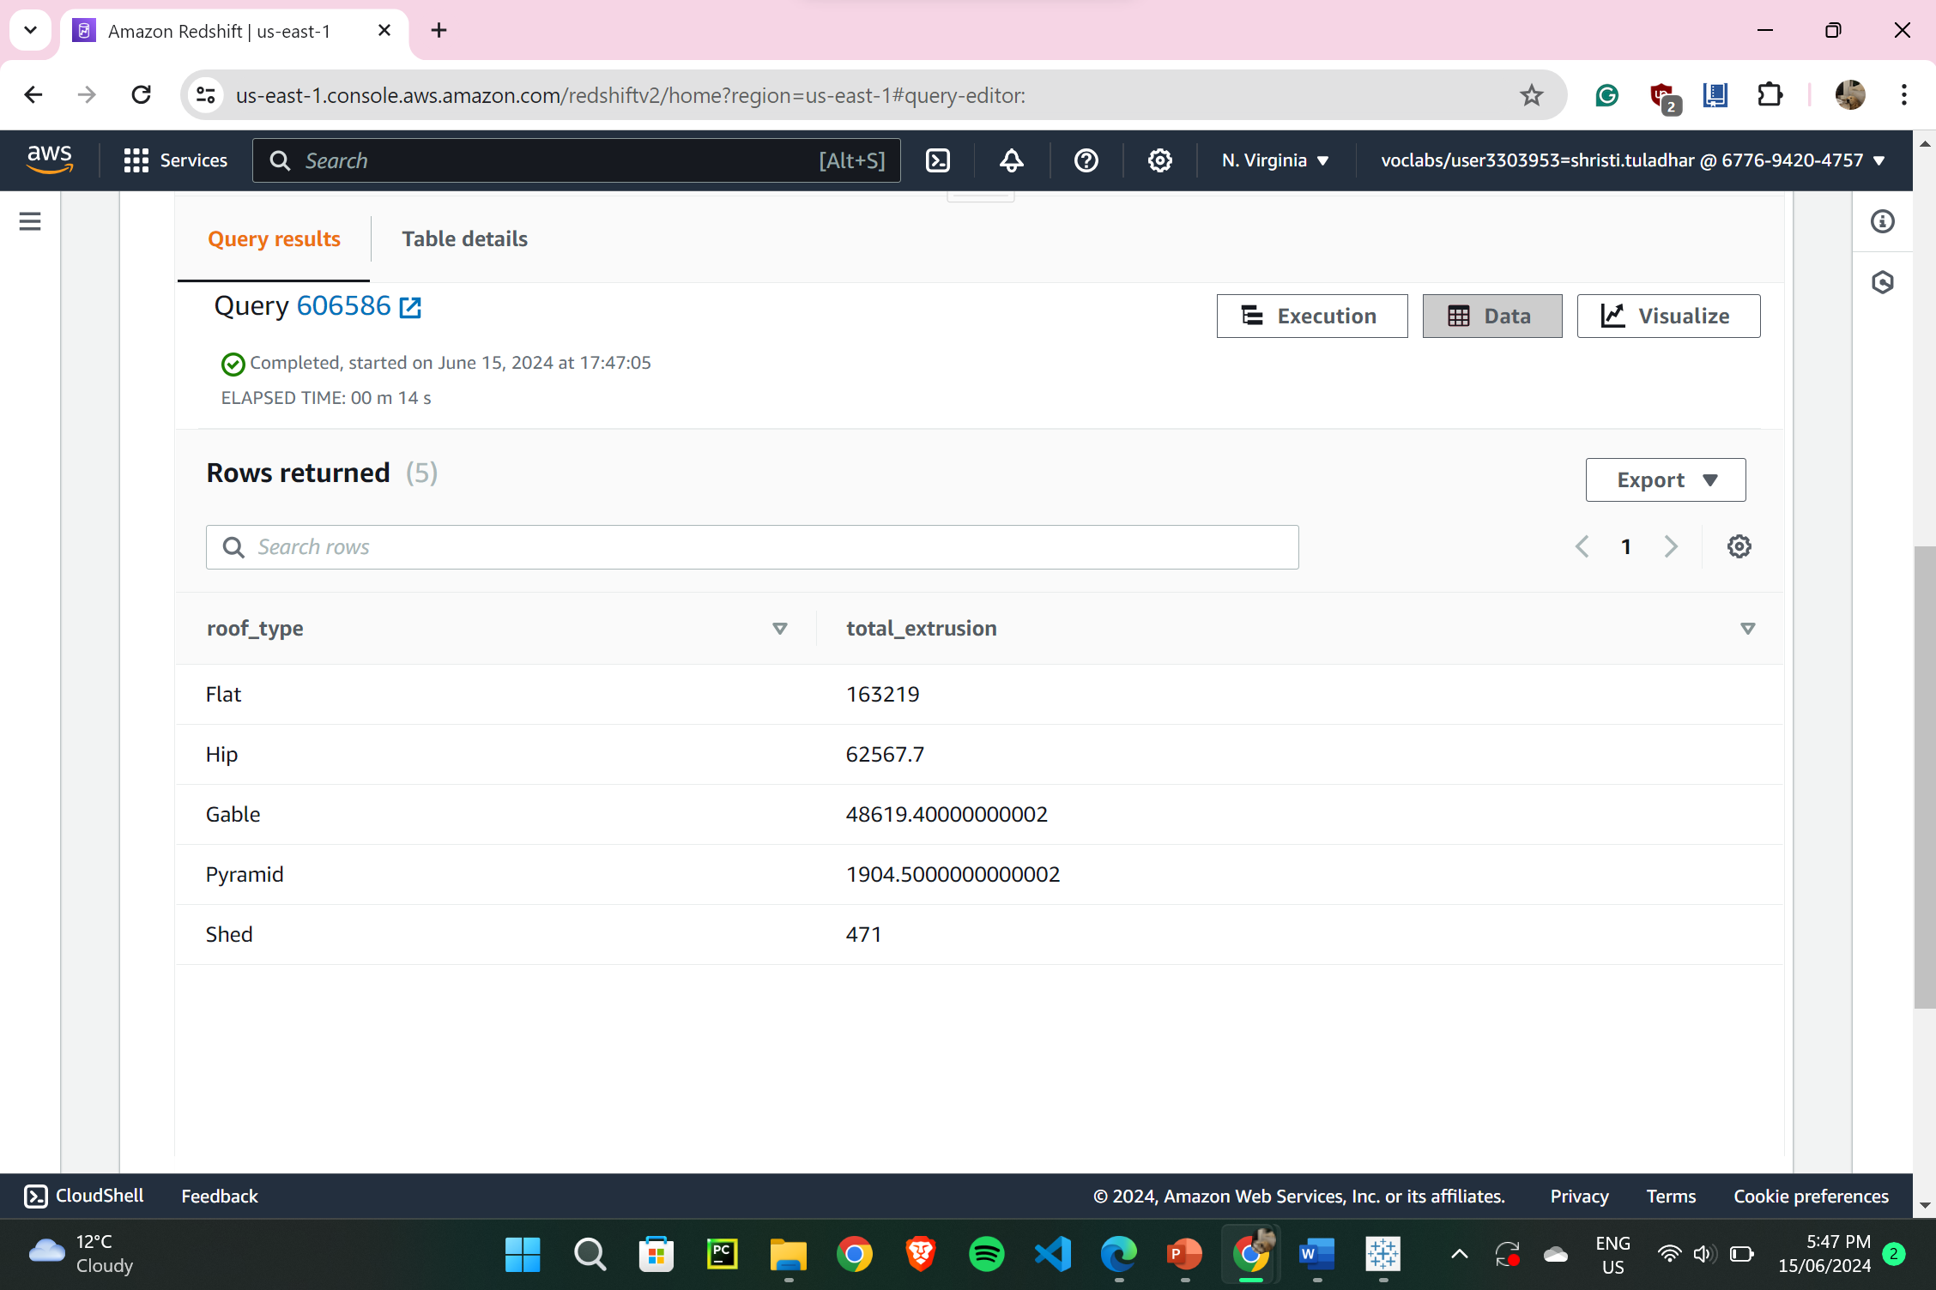

1. **Connecting Tableau with Redshift cluster:**

* Firstly, modifying redshift-cluster-1 to make it publicly accessible.

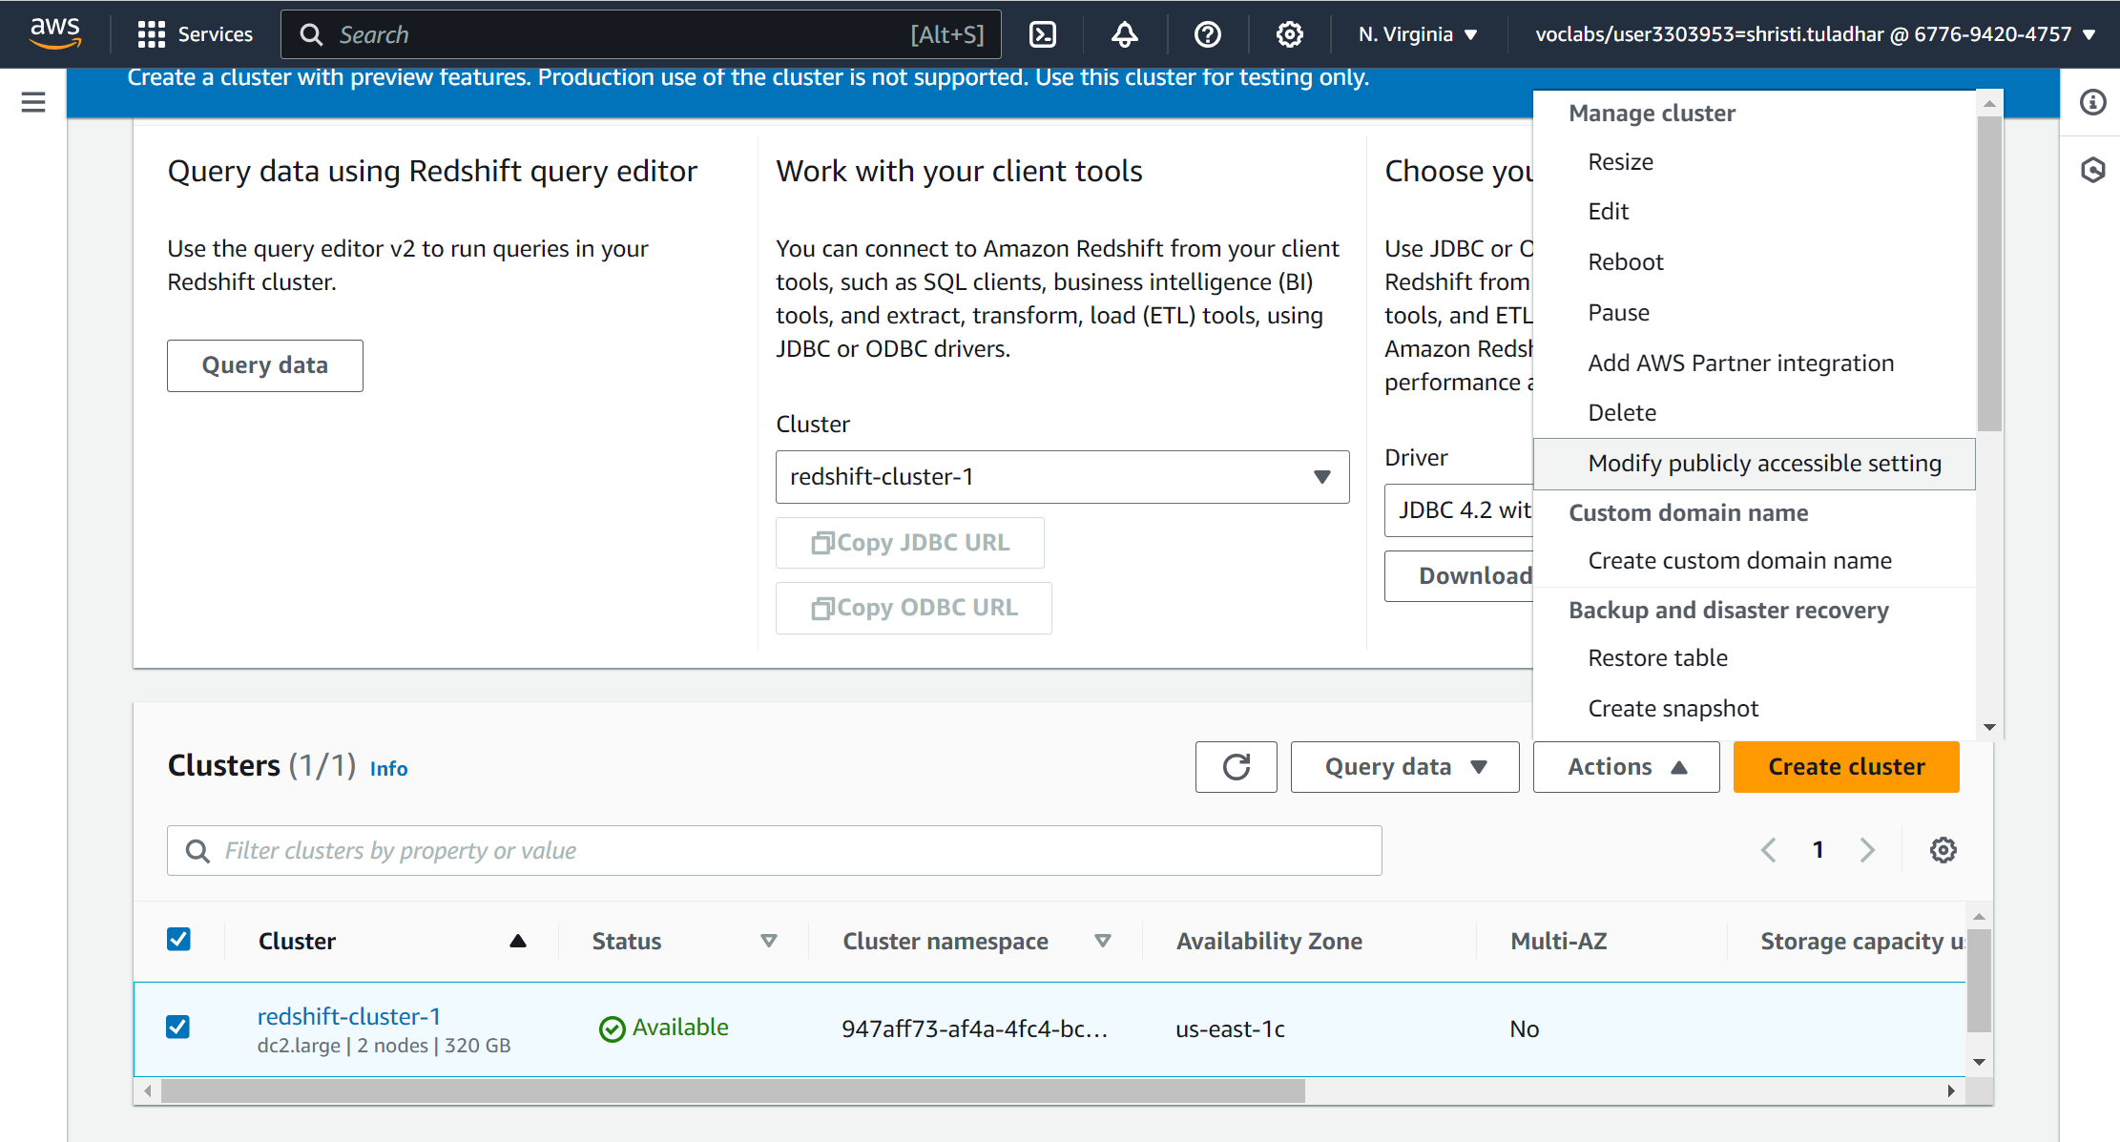

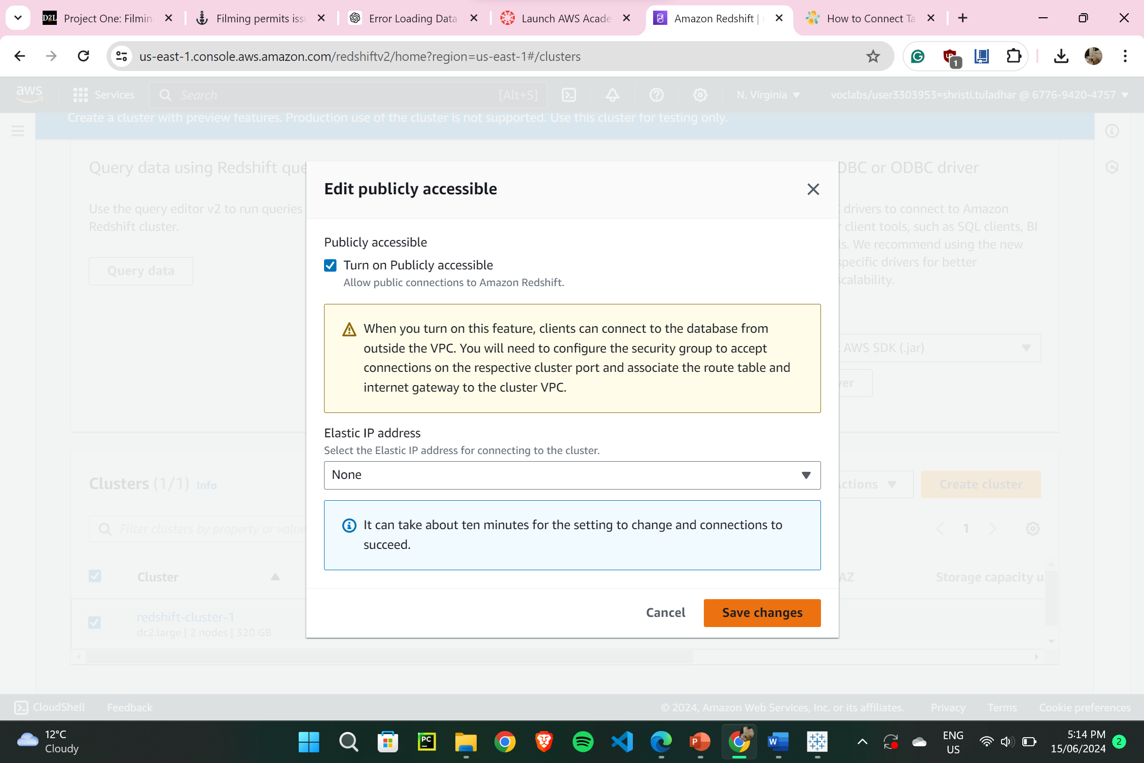

(Now, Downloaded & Installed ODBC Driver, and in tableau; connecting to amazon redshift, server = (Amazon Redshift – Redshift Cluster 1 – Endpoint), database = dev, username = awsuser, password = Passw0rd1)

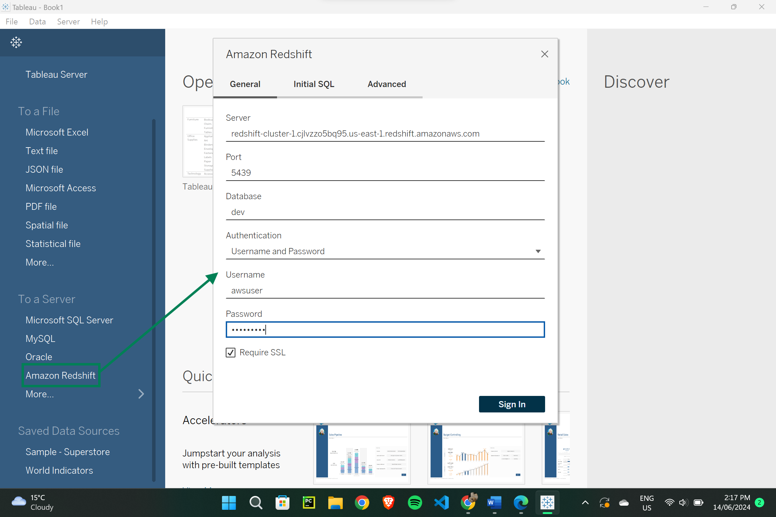

Tableau connected with dev database:

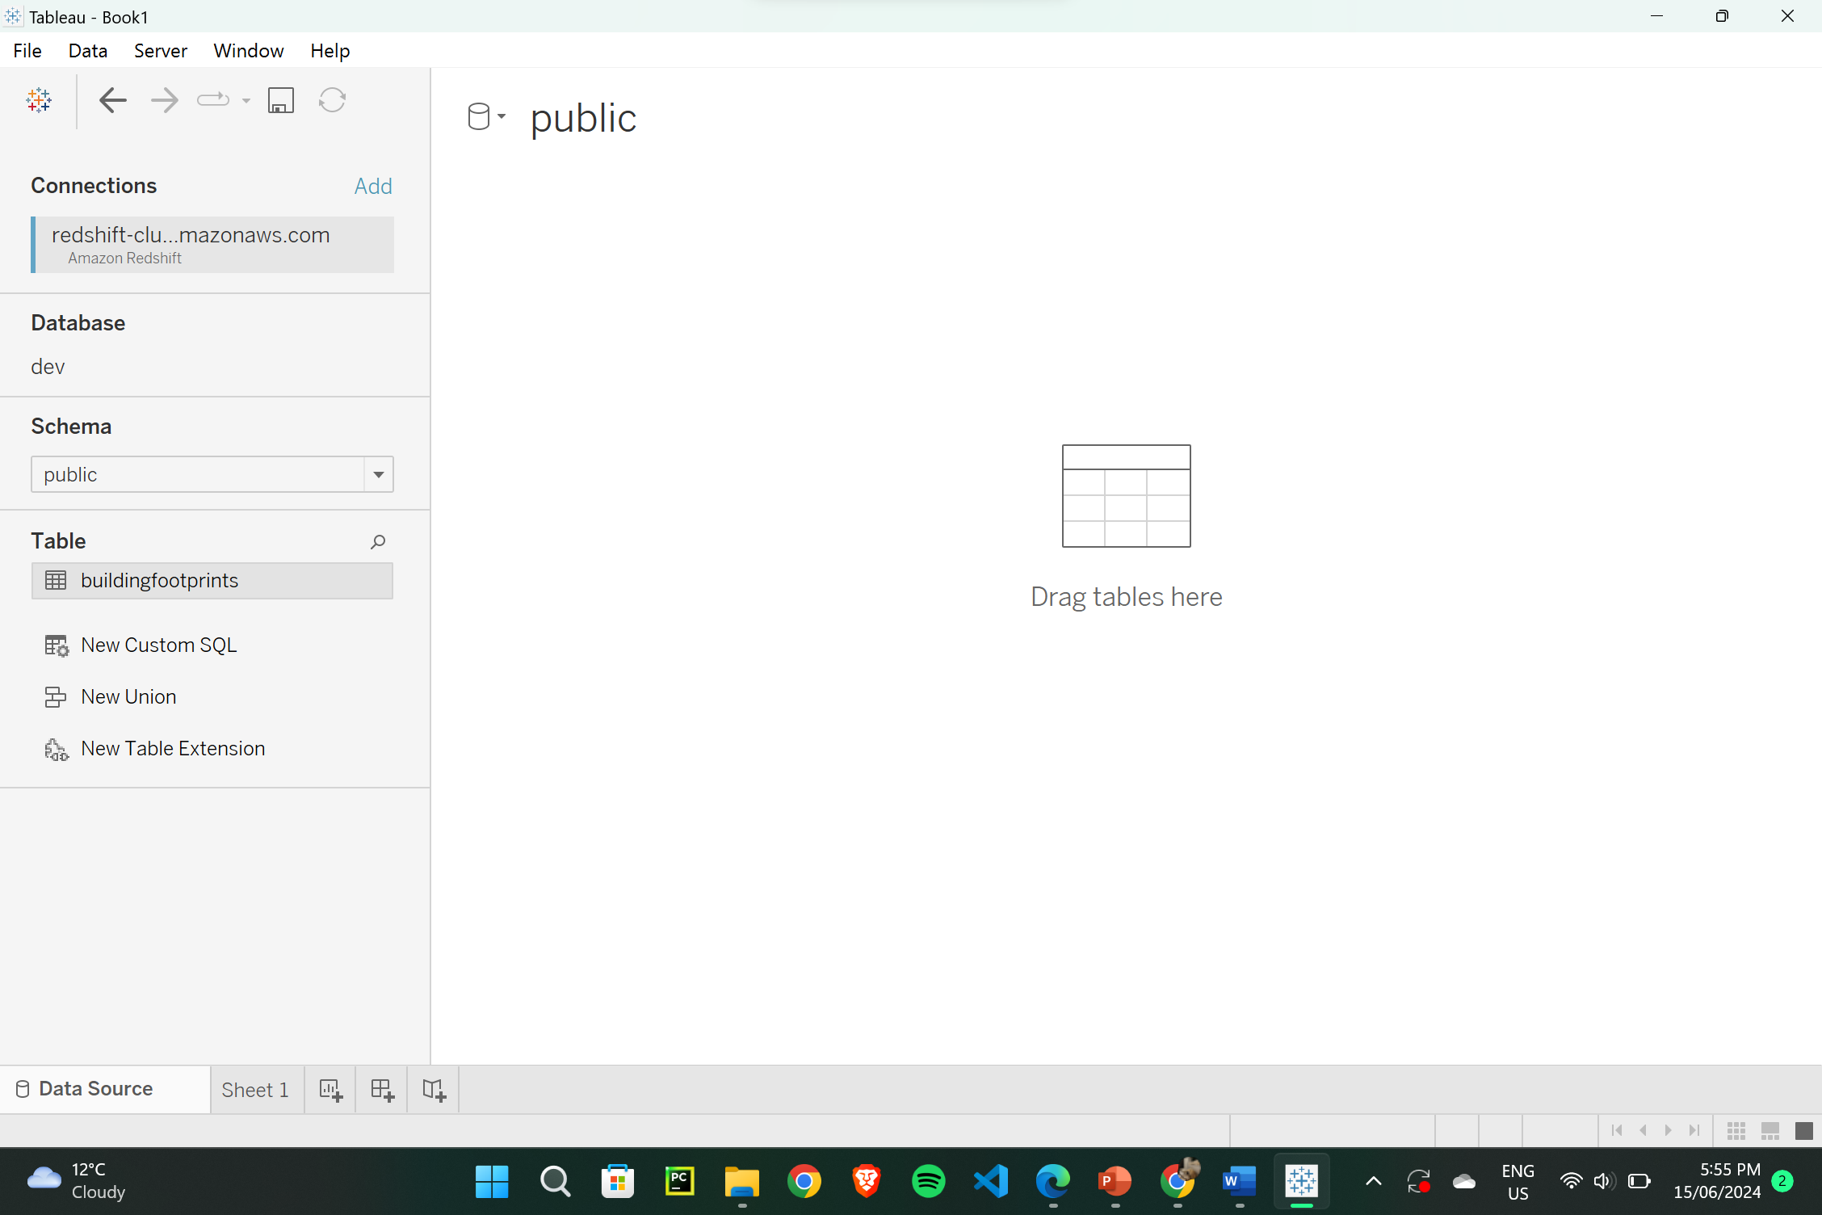

1. **Tableau – Live Data Connection**

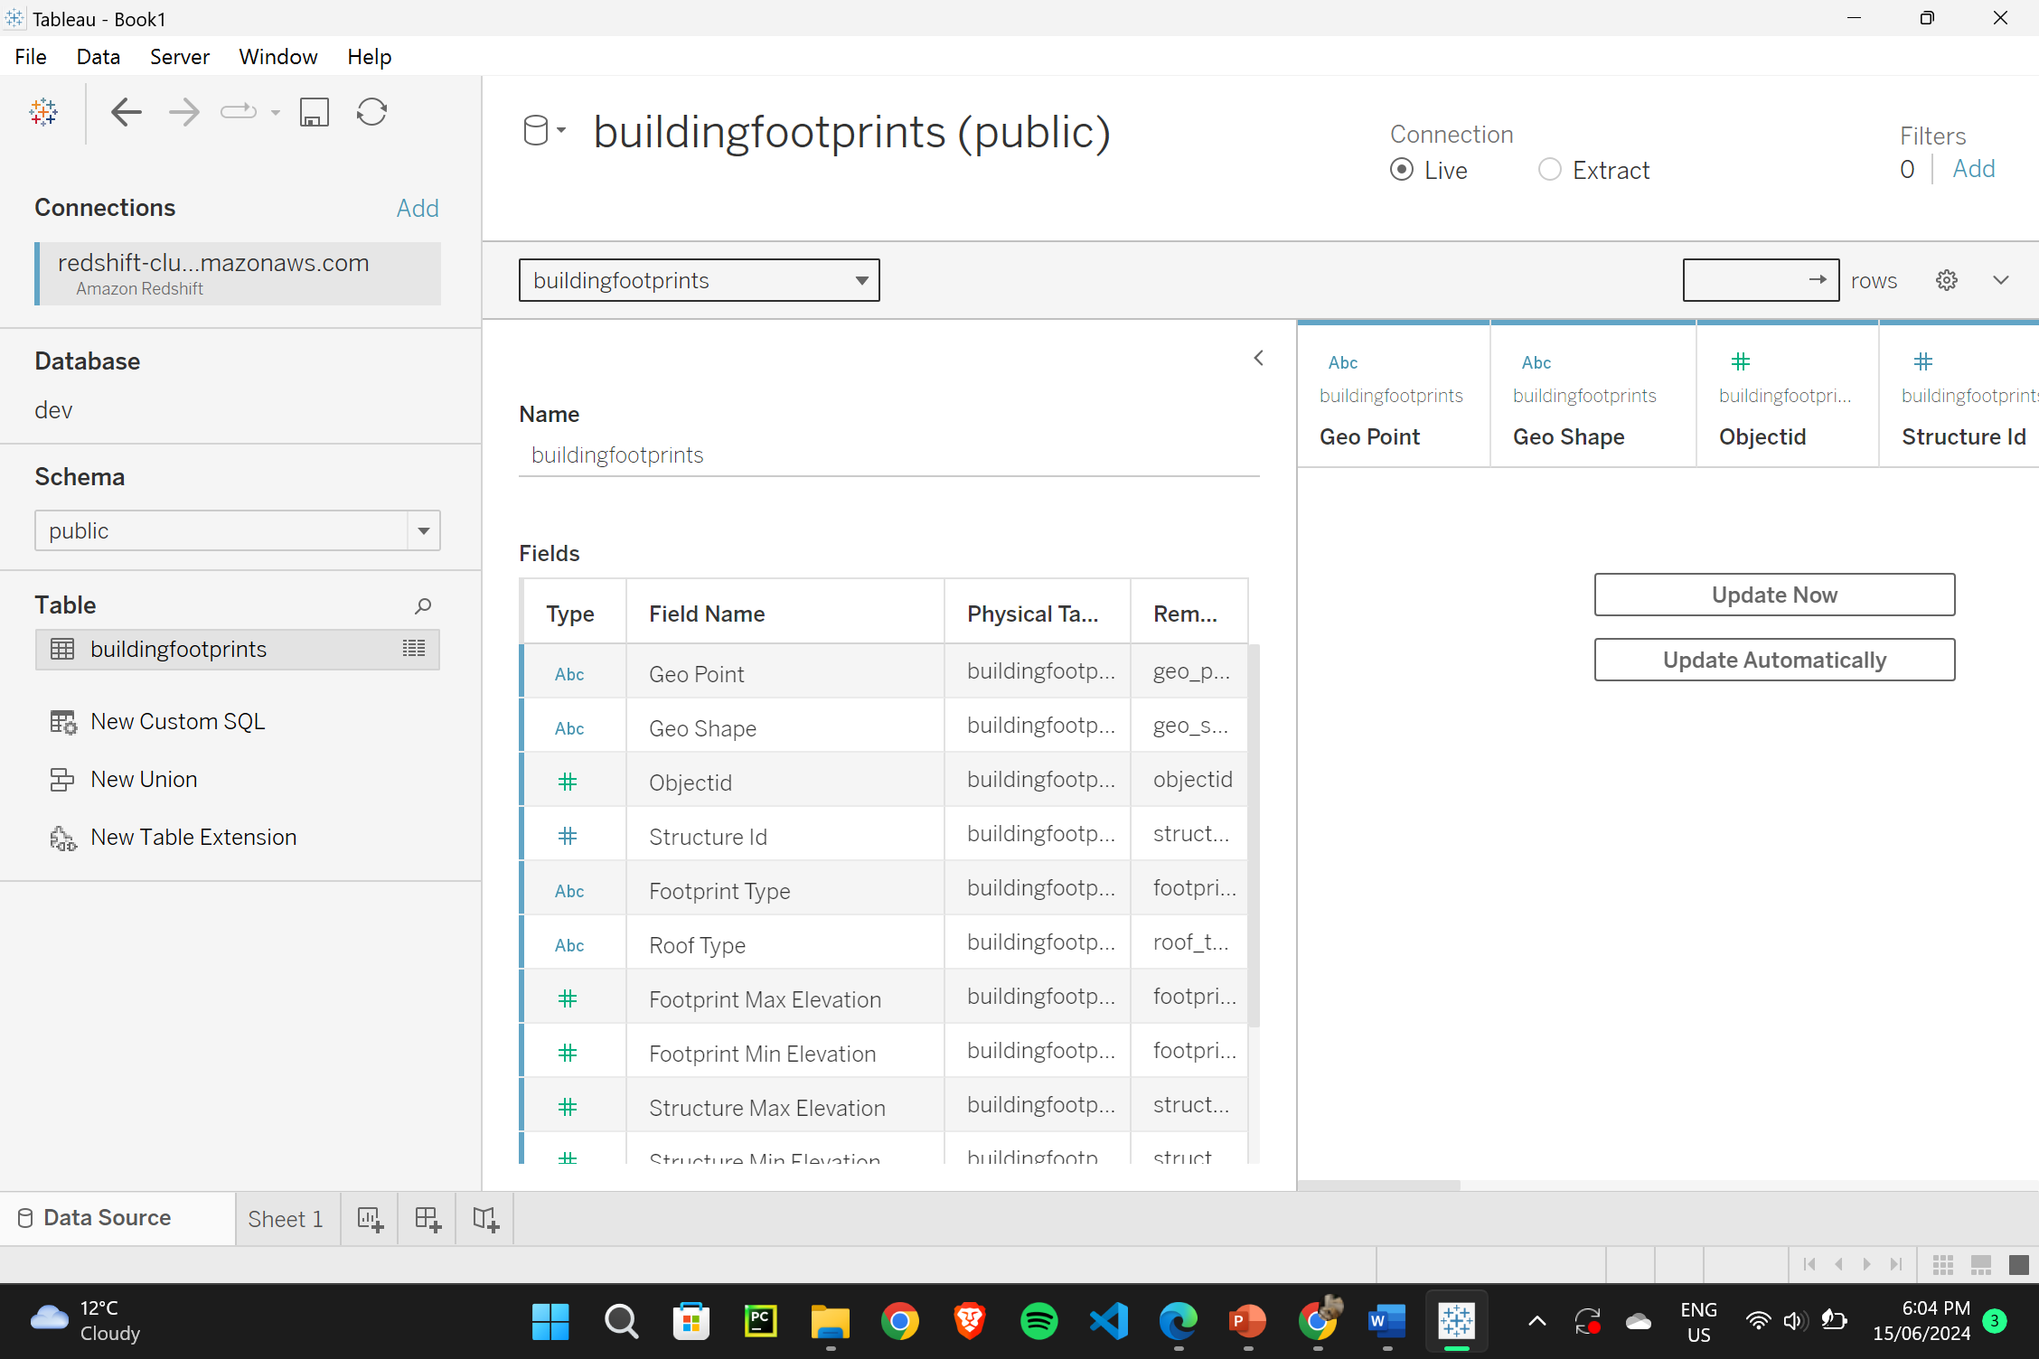

1. **Tableau - Live Data Synchronization**

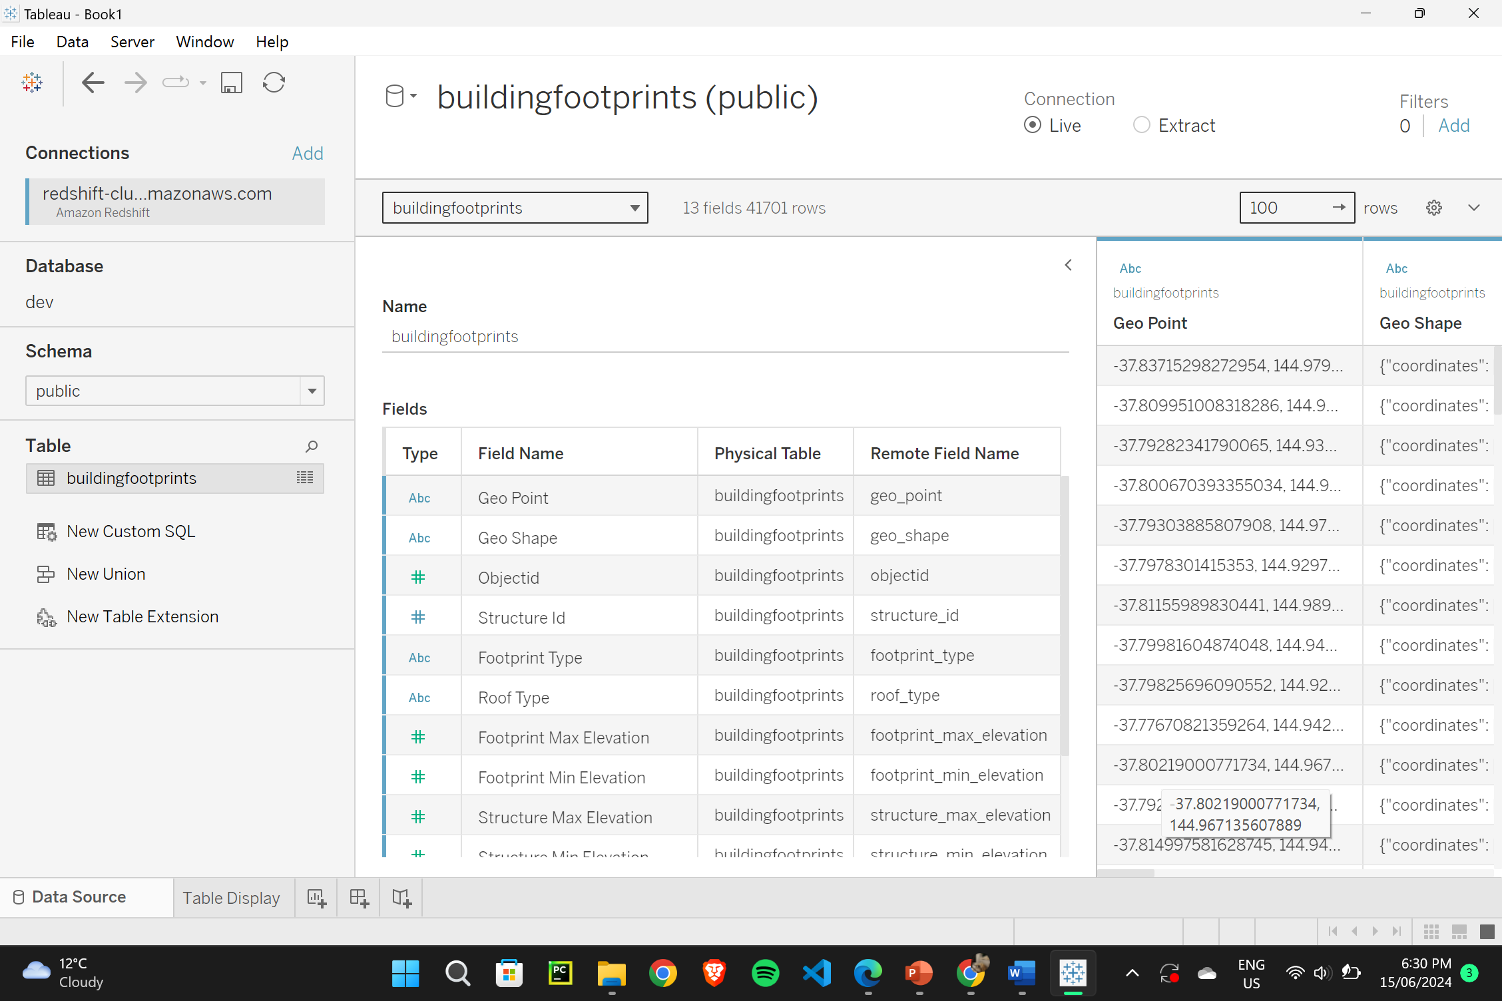

1. **Tableau - Table Display**

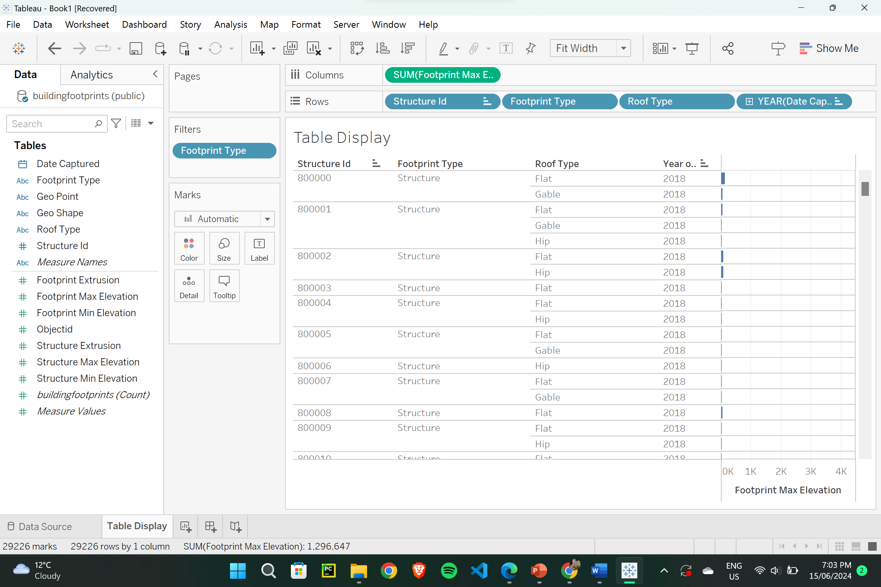

1. **Creating charts/graphs PLUS a Dashboard in Tableau.**
2. Bar Chart

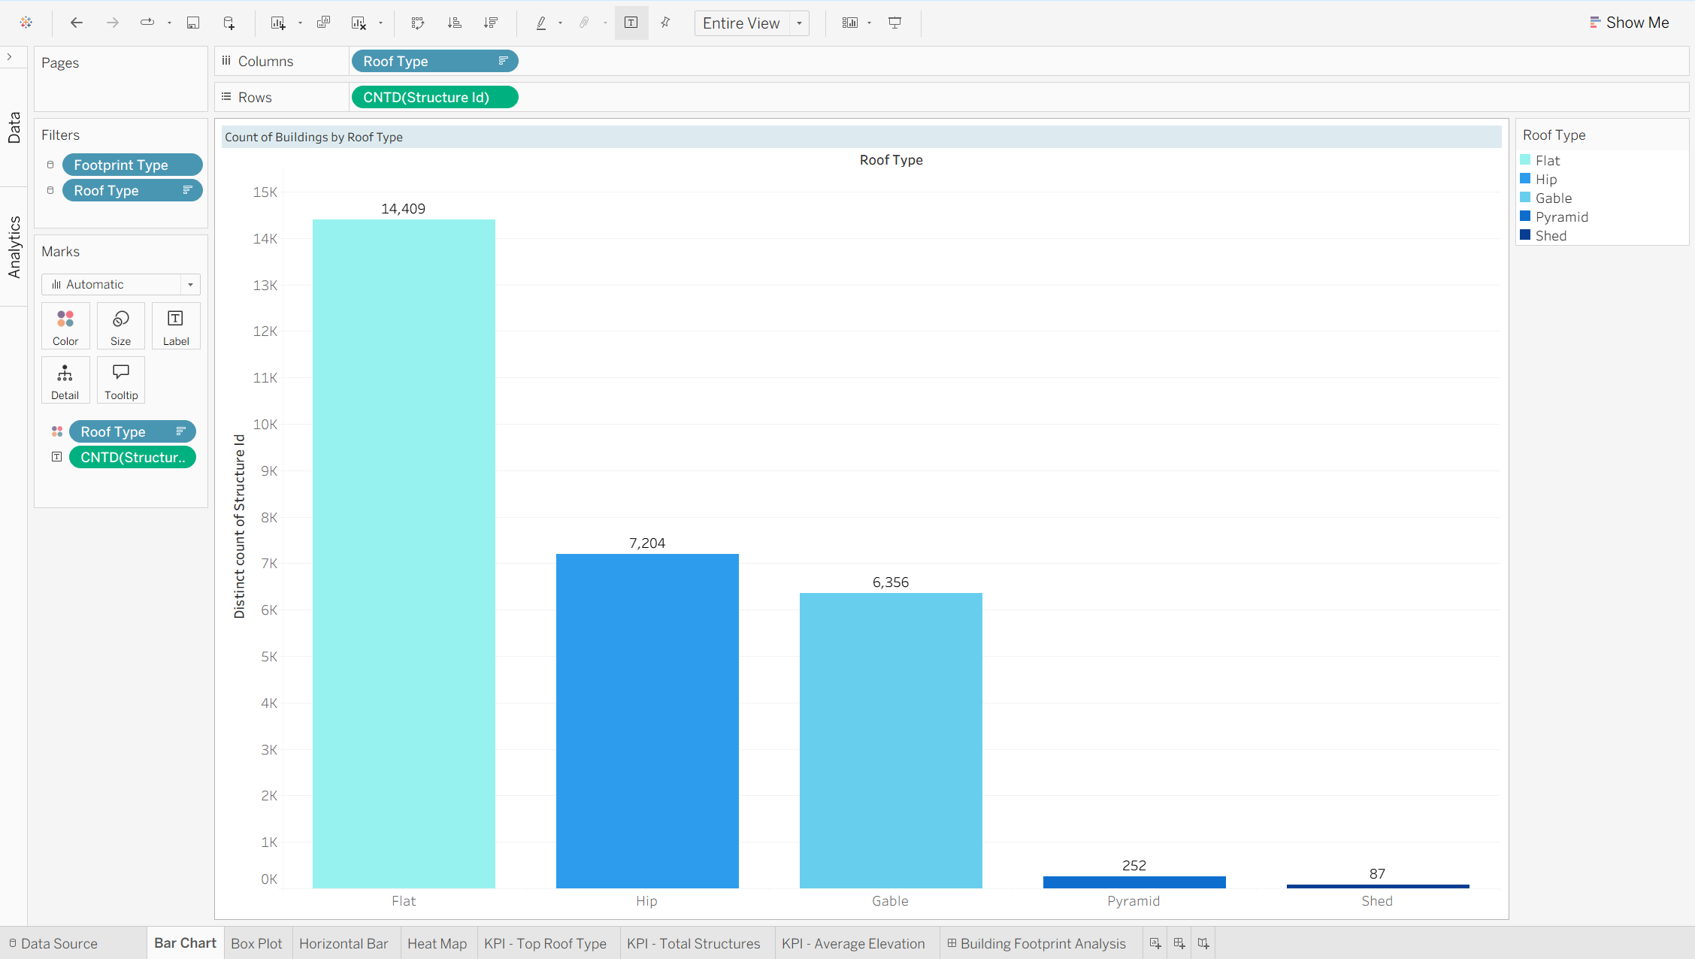

1. Box Plot

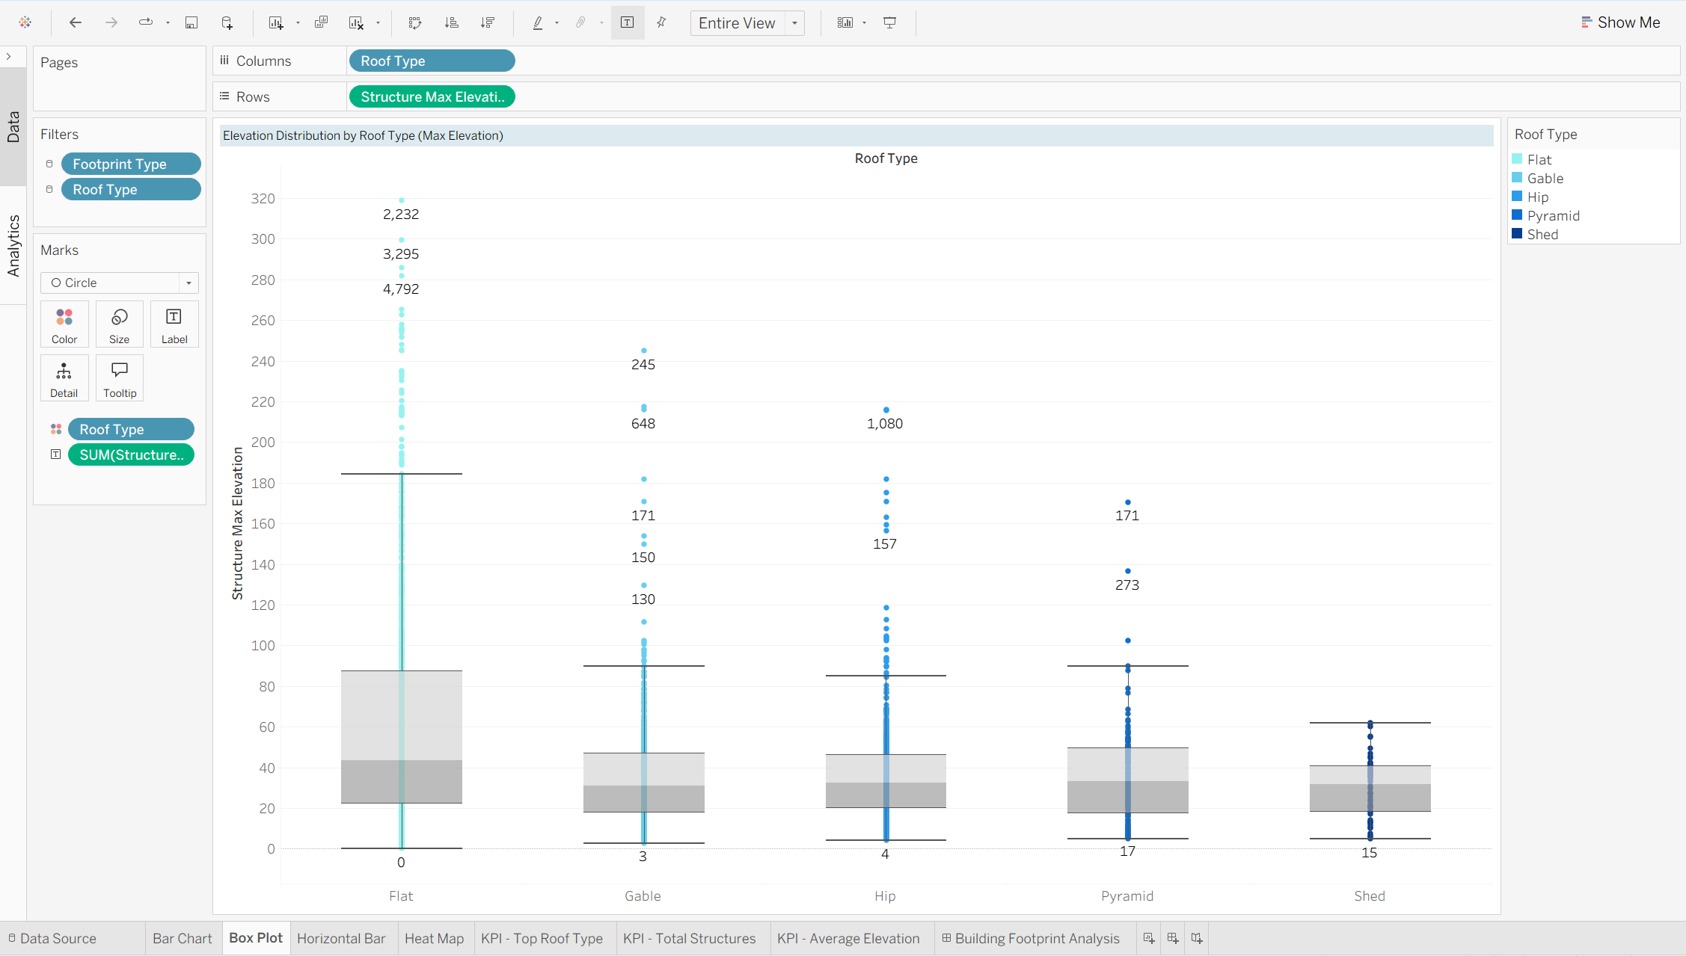

1. Horizontal Bar

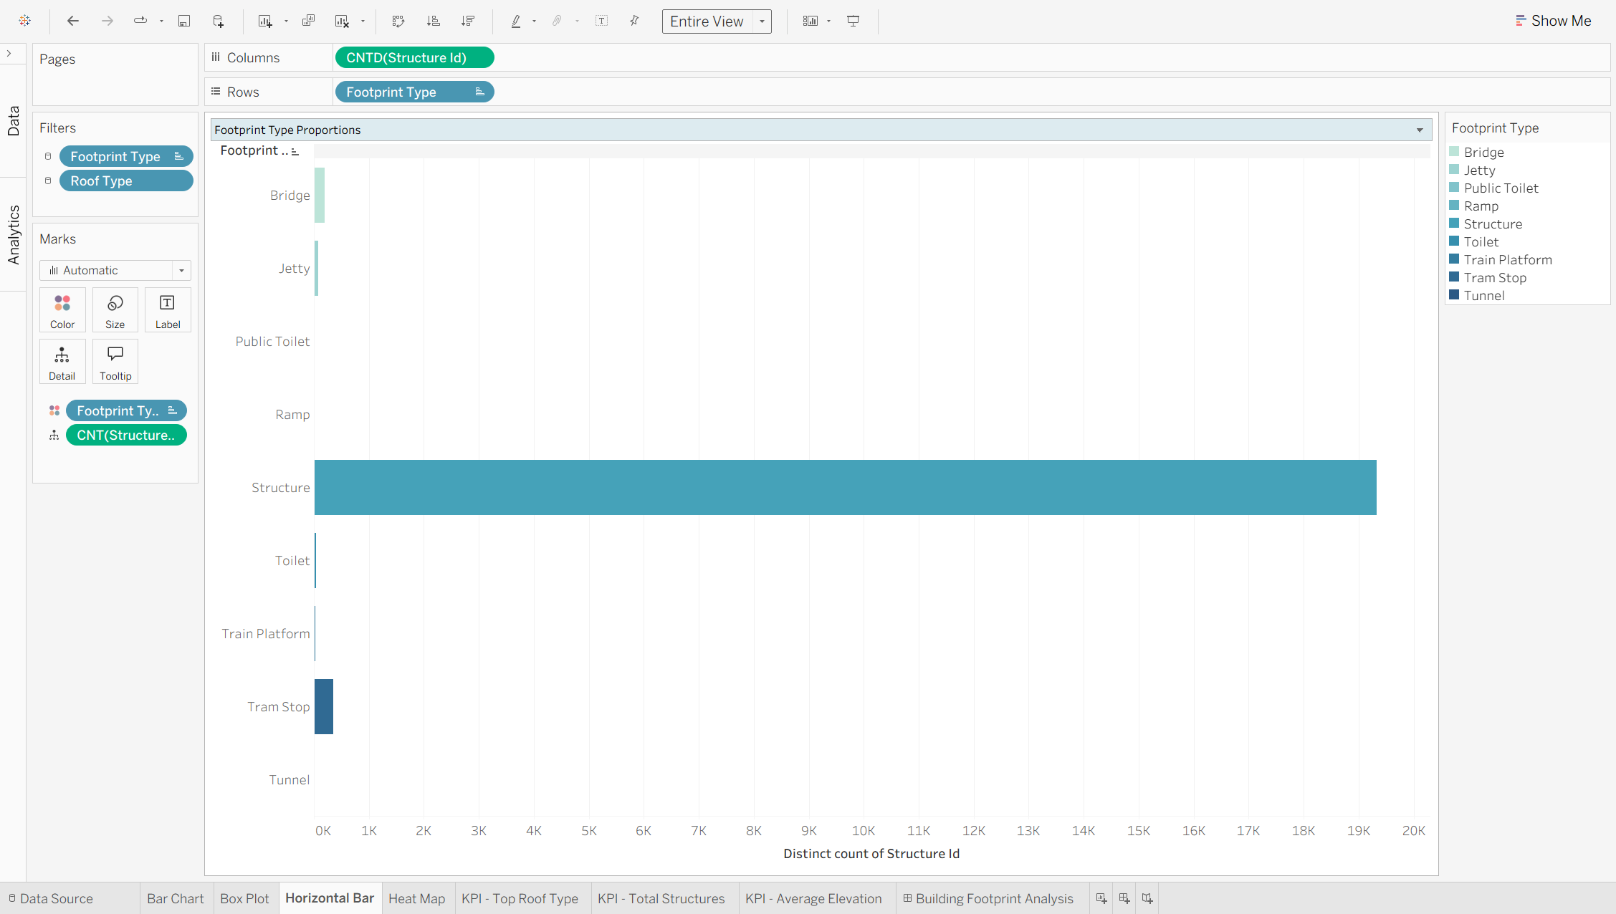

1. Heat Map

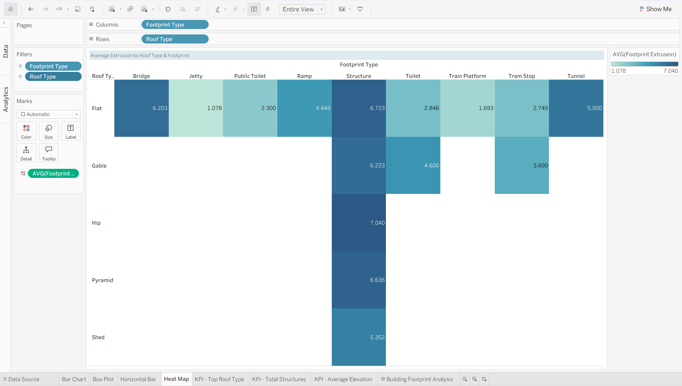

1. Dashboard

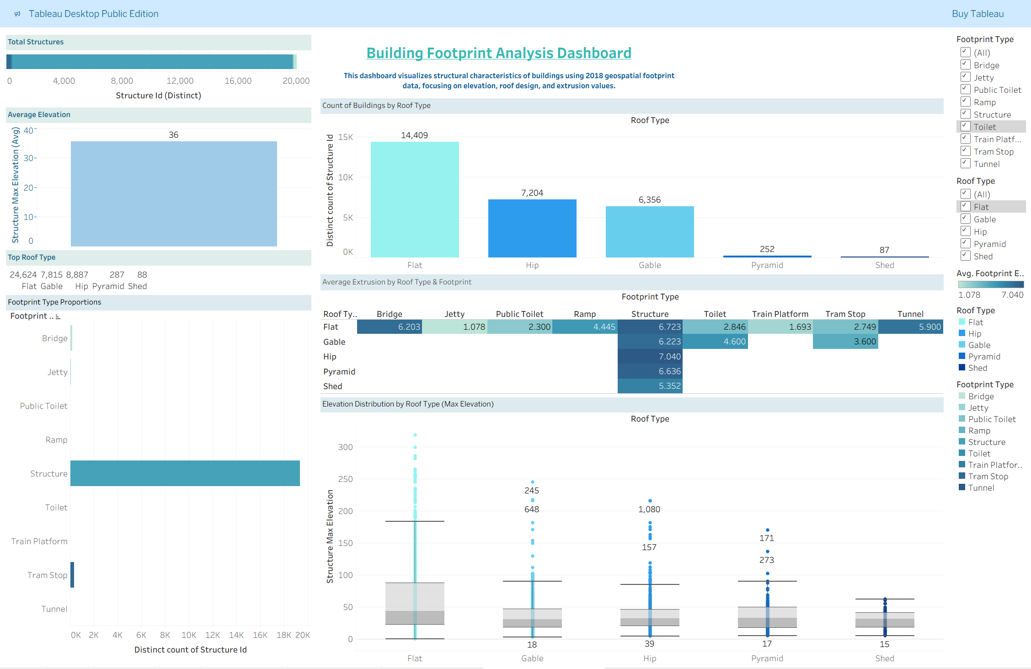

1. **AWS Details: Project Hours/Cost**

* Table Structure for tasks and hours spent:

|  |  |  |
| --- | --- | --- |
| **Task Description** | **Hours Spent** | **Notes** |
| Creating S3 bucket & uploading the project file | 15 minutes | Successfully created an S3 bucket and uploaded the project CSV file for further processing. |
| Setting up Amazon Redshift and configuring security group | 0.5 hours | Completed initial setup of Amazon Redshift, including security group configuration to ensure secure data access. |
| Connecting Redshift cluster to the database and creating a table using SQL | 0.5 hours | Established connection between the Redshift cluster and the database and created the required table using SQL commands. |
| Loading data into Amazon Redshift | 0.5 hours | Uploaded CSV data files into Amazon Redshift, preparing for data analysis. |
| Debugging errors during data loading and data cleaning using Python | 2 hours | Identified and resolved several data loading issues and cleaned the dataset using Python scripts. |
| Executing SQL queries | 0.5 hours | Ran various SQL queries (simple and complex) to validate data. |
| Connecting Tableau to Amazon Redshift and installing ODBC driver) | 0.5 hours | Set up live data connection between Tableau and Amazon Redshift by installing the required ODBC driver. |
| Creating visualizations in Tableau | 1 hour | Designed various charts and dashboards in Tableau to visualize data insights. |
| Architecting AWS infrastructure | 1.5 hours | Outlined the AWS architecture for the project, detailing each component's role and interaction. |
| Reviewing project documentation | 1.5 hours | Thoroughly reviewed and updated the project documentation. |

1. **Cost Summary through Biling & Cost Management console:**

